UNITED STATES
SECURITIES AND EXCHANGE COMMISSION
Washington, D.C. 20549
FORM 8-K
CURRENT REPORT
Pursuant to Section 13 or 15(d)
of the Securities Exchange Act of 1934
Date of Report (Date of earliest event reported): August 11, 2026
ABSCI CORPORATION
(Exact name of registrant as specified in its charter)
Delaware |  |  |  |  |  | 001-40646 |  |  |  |  |  | 85-3383487
(State or other jurisdiction  of incorporation) |  |  |  |  |  | (Commission  File Number) |  |  |  |  |  | (I.R.S. Employer  Identification No.)
18105 SE Mill Plain Blvd
Vancouver, WA 98683
(Address of principal executive offices, including zip code)
(360) 949-1041
(Registrant’s telephone number, including area code)
Not Applicable
(Former Name or Former Address, if Changed Since Last Report)
Check the appropriate box below if the Form 8-K filing is intended to simultaneously satisfy the filing obligation of the registrant under any of the following provisions:
☐ |  |  | Written communications pursuant to Rule 425 under the Securities Act (17 CFR 230.425)
☐ |  |  | Soliciting material pursuant to Rule 14a-12 under the Exchange Act (17 CFR 240.14a-12)
☐ |  |  | Pre-commencement communications pursuant to Rule 14d-2(b) under the Exchange Act (17 CFR 240.14d-2(b))
☐ |  |  | Pre-commencement communications pursuant to Rule 13e-4(c) under the Exchange Act (17 CFR 240.13e-4(c))
Securities registered pursuant to Section 12(b) of the Act:
Title of each class |  |  | Trading Symbol(s) |  |  | Name of each exchange on which registered
Common Stock, $0.0001 par value per share |  |  | ABSI |  |  | The Nasdaq Global Select Market
Indicate by check mark whether the registrant is an emerging growth company as defined in Rule 405 of the Securities Act of 1933 (§ 230.405 of this chapter) or Rule 12b-2 of the Securities Exchange Act of 1934 (§ 240.12b-2 of this chapter).
Emerging growth company ☒
If an emerging growth company, indicate by check mark if the registrant has elected not to use the extended transition period for complying with any new or revised financial accounting standards provided pursuant to Section 13(a) of the Exchange Act. ☐

Item 2.02. Results of Operations and Financial Condition.

On August 11, 2026, Absci Corporation (the “Company”) announced its financial results for the second quarter ended June 30, 2026. A copy of the press release is being furnished as Exhibit 99.1 to this Current Report on Form 8-K.

The information contained in Item 2.02 of this Current Report on Form 8-K, together with Exhibit 99.1 hereto, is being furnished and shall not be deemed to be “filed” for the purposes of Section 18 of the Securities Exchange Act of 1934, as amended (the “Exchange Act”), or otherwise subject to the liabilities of that section and shall not be incorporated by reference in any filing under the Securities Act of 1933, as amended, or the Exchange Act, except as shall be expressly set forth by specific reference in such filing.

Item 8.01. Other Events.

From time to time, the Company presents and/or distributes slides and presentations to the investment community to provide updates and summaries of its business. On August 11, 2026, the Company released a presentation which includes certain internal pipeline program updates, which is available on the “News & Events” section of the Company’s website. A copy of this presentation is filed as Exhibit 99.2 to this Current Report on Form 8-K and is incorporated by reference herein.

Item 9.01. Financial Statements and Exhibits.
(d) Exhibits
99.1 Press Release issued by the Company on August 11, 2026, furnished herewith.
99.2 Absci Corporate Presentation August 2026

SIGNATURE
Pursuant to the requirements of the Securities Exchange Act of 1934, the registrant has duly caused this report to be signed on its behalf by the undersigned hereunto duly authorized.
 |  |  | Absci Corporation
Date: August 11, 2026 |  |  | By: |  |  | /s/ Shelby Walker
 |  |  |  |  |  | Shelby Walker
 |  |  |  |  |  | Chief Legal Officer

Exhibit 99.1



Absci Reports Business Updates and Second Quarter 2026 Financial and Operating Results
Announced positive interim Phase 1 data from the HEADLINE™ trial of ABS-201
Completed $100 million underwritten offering, including $40 million strategic investment from Eli Lilly & Company
Cash, cash equivalents, and marketable securities now sufficient to fund operations into the second half of 2028
VANCOUVER, Wash. and NEW YORK, August 11, 2026 – Absci Corporation (Nasdaq: ABSI), a clinical-stage biopharmaceutical company advancing breakthrough therapeutics designed with generative AI, today reported financial and operating results for the quarter ended June 30, 2026.
“The positive Phase 1 interim data from our HEADLINE trial, combined with our strengthened balance sheet and advancing platform, position us well for what comes next,” said Sean McClain, Founder and CEO. “We are fast approaching defining moments for Absci, with interim proof-of-concept data for pattern hair loss later this year and our full 26-week readout in early 2027. These results have the potential to demonstrate ABS-201's regenerative mechanism and change the treatment paradigm for the millions of people living with pattern hair loss. And this is just the beginning for our prolactin receptor franchise within our overall proprietary pipeline, with endometriosis expansion ahead.”
Recent Highlights
•Reported positive interim Phase 1 data from Absci's first-in-human trial of ABS-201 (anti-PRLR antibody). Blinded, aggregate interim data suggest study drug was well tolerated and exhibited a favorable safety and tolerability profile. Based on available interim pharmacokinetic (PK) data across all four single ascending dose (SAD) cohorts, half-life for ABS-201 is estimated to be at least 65 days. These results support the potential for dosing two or three times over a six month period, pending confirmation through continued follow-up across all cohorts.
•Completed $100 million underwritten offering, including a $40 million strategic equity investment from Eli Lilly & Company, and participation from leading financial institutions including Adage, BVF Partners, Columbia Threadneedle, Invus, Redmile, and a large investment management firm.
Exhibit 99.1

•Continuing to dose participants with pattern hair loss (PHL) in multiple ascending dose (MAD) portion of the HEADLINE trial. Absci anticipates reporting interim proof-of-concept data from this study in the second half of 2026 and full proof-of-concept data in early 2027.
Prolactin (PRL) Program Portfolio
•ABS-201 for Pattern Hair Loss: ABS-201, currently undergoing Phase 1/2a studies, is being developed for pattern hair loss (PHL). Absci believes that ABS-201, if successfully developed and approved, could provide a significant new category of PHL treatment that offers the potential for durable hair growth with a convenient administration profile. In June, Absci announced positive interim Phase 1 data from the HEADLINE trial, demonstrating that the study medication appears well tolerated, with favorable safety data across all blinded single ascending dose (SAD) cohorts. Additionally, the estimated half-life of at least 65 days supports the potential for ABS-201's targeted dosing interval of two or three injections over a six-month period. Absci anticipates reporting interim proof-of-concept data in the second half of 2026 and full proof-of-concept data in early 2027.
•ABS-201 for Endometriosis: Endometriosis is a condition that impacts a large, underserved patient population with significant unmet medical need and poor standard of care. Endometriosis is prevalent in up to 10% of women worldwide, including an estimated 9 million women in the U.S., and there is currently no FDA-approved disease-modifying therapy. ABS-201 for endometriosis represents a novel non-sex steroid hormone mechanism, with potential to be disease-modifying, act on both pain and lesion growth, and offer an improved safety profile. With the safety, tolerability, and PK data generated in the ongoing HEADLINE trial, Absci anticipates initiation of a Phase 2 clinical trial for endometriosis in the fourth quarter of 2026, with potential proof-of-concept data in the second half of 2027.
•ABS-202 for Undisclosed I&I Indication: ABS-202 is an anti-PRLR antibody in preclinical development for an undisclosed I&I indication.
Other Internal Pipeline Programs and Partnerships
Absci continues to advance its ongoing drug creation partnered programs, as well as partnering discussions for other internal programs at various stages of preclinical and clinical development.
Absci’s new partnership with Eli Lilly is tailored around the clinical development strategy for ABS-201, and does not confer any program rights to Eli Lilly. As part of Eli Lilly’s $40 million strategic investment in Absci, a representative from Eli Lilly has joined Absci’s Endometriosis Advisory Board.
Recent Publications, Presentations, and Abstracts
Exhibit 99.1

Peer-Reviewed Publications
•mAbs 2026: "Efficient inference of non-polyreactive antibody variants dependent on local fine-tuning"
Accepted Presentations and Abstracts
•American Academy of Dermatology Innovation Academy (AAD) 2026: "ABS-201, an AI-designed Antibody, Blocks Prolactin/PRLR Signaling and Presents a Novel Biologic Strategy for the Treatment of Androgenetic Alopecia"
•Summer RosettaCon 2026: "Origin-1: A Generative AI Platform for De Novo Antibody Design Against Novel Epitopes"
•Third Barcelona Hair Meeting 2026: "ABS-201-Mediated Prolactin Receptor Inhibition Promotes Hair Growth in Androgen-Sensitive Male Scalp"
•European Academy of Dermatology and Venereology Congress (EADV) 2026: "Prolactin Receptor Antagonism by ABS-201 Drives Hair Follicle Growth and Stem/Progenitor Cell Expansion in Human Male Scalp Skin"
•American Society for Reproductive Medicine (ASRM) 2026: "Prolactin Receptor Blockade With Anti-Prolactin Receptor Antibody (Anti-PRLR Ab) Relieves Pain and Inflammation in a Homologous Transplant Mouse Model of Endometriosis"
Second Quarter 2026 Financial Results
Revenue was $0.3 million for the three months ended June 30, 2026, compared to $0.6 million for the three months ended June 30, 2025.
Research and development expenses were $22.6 million for the three months ended June 30, 2026, compared to $20.5 million for the three months ended June 30, 2025. This increase was primarily driven by advancement of Absci's internal programs, including direct costs associated with external preclinical and clinical development of ABS-201, offset by a decrease in personnel-related costs.
Selling, general, and administrative expenses were $9.2 million for the three months ended June 30, 2026, compared to $8.5 million for the three months ended June 30, 2025. This increase was primarily due to stock-based compensation and other administrative costs.
Net loss was $33.2 million for the three months ended June 30, 2026, compared to $30.6 million for the three months ended June 30, 2025.
Cash, cash equivalents, and marketable securities as of June 30, 2026 were $201.1 million, compared to $125.7 million as of March 31, 2026. The cash, cash equivalents, and marketable securities as of June 30, 2026 reflects $93.6 million of net proceeds from Absci's underwritten offering completed in June 2026.
Exhibit 99.1

Based on the company's current projections, Absci now believes its cash, cash equivalents, and marketable securities will be sufficient to fund its operating plans into the second half of 2028.
Webcast Information
Absci will host a conference call to discuss its second quarter 2026 business updates and financial and operating results on Tuesday, August 11, 2026 at 4:30 p.m. Eastern Time / 1:30 p.m. Pacific Time. A webcast of the conference call can be accessed at investors.absci.com. The webcast will be archived and available for replay for at least 90 days after the event.
About Absci
Absci is advancing the future of drug discovery with generative design to create better biologics for patients, faster. Our Integrated Drug Creation™ platform combines cutting-edge AI models with a synthetic biology data engine, enabling the rapid design of innovative therapeutics that address challenging therapeutic targets. Absci’s approach leverages a continuous feedback loop between advanced AI algorithms and wet lab validation. Each cycle refines our data and strengthens our models, facilitating rapid innovation and enhancing the precision of our therapeutic designs. Alongside collaborations with top pharmaceutical, biotech, tech, and academic leaders, Absci is advancing its own pipeline of AI designed therapeutics including ABS-201™, a groundbreaking innovation in hair regrowth with the potential to redefine treatment possibilities for androgenetic alopecia, commonly known as male and female pattern hair-loss. ABS-201 is also being investigated as a potential “best-in-class” therapeutic for endometriosis, a condition with significant unmet medical need and market potential. Absci is headquartered in Vancouver, WA, with AI Research Labs in New York City and Serbia, and an Innovation Center in Switzerland. Learn more at www.absci.com or follow us on LinkedIn (@absci), X (@Abscibio) and YouTube.
Forward-Looking Statements
Statements contained in this press release regarding matters that are not historical facts are “forward-looking statements” within the meaning of the Private Securities Litigation Reform Act of 1995. Because such statements are subject to risks and uncertainties, actual results may differ materially from those expressed or implied by such forward-looking statements. Such statements include, but are not limited to, statements regarding any or all of the following: development and clinical progress of Absci's pipeline programs, including ABS-201, the design, enrollment, conduct, and timelines of our ongoing Phase 1/2a HEADLINE™ trial of ABS-201 for androgenetic alopecia; the anticipated timing of an interim proof-of-concept data readout for ABS-201 in the second half of 2026; the potential advancement of ABS-201 into Phase 3 development; the anticipated initiation of a Phase 2 clinical trial of ABS-201 for endometriosis in the fourth quarter of 2026 and a potential proof-of-concept readout in the second half of 2027; the anticipated characteristics and product profile of ABS-201 as a drug product, our target product profile
Exhibit 99.1

and its attributes, the terms, anticipated benefits and strategic rational of our collaboration with Elil Lilly including Eli Lilly's participation in our Endometriosis Advisory Board; the potential for an expedited development pathway including the possibility of advancing directly from Phase 1/2a into Phase 3, our planned engagement with the FDA regarding development strategy, and potential market opportunity and commercial prospects for ABS-201 in pattern hair loss and endometriosis; projections regarding potential market opportunity based on various assumptions, including potential regulatory approval, the final approved label, and the evolving competitive landscape, any of which could cause our actual addressable market to differ materially from these projections; the capabilities, development, and anticipated benefits of our ATLAS platform; Absci’s strategy, goals, anticipated financial performance and the sufficiency of its cash, cash equivalents and marketable securities to fund operating plans into the second half of 2028; and expected benefits of its collaborations with partners. Risks that contribute to the uncertain nature of the forward-looking statements include, without limitation, the risks and uncertainties discussed under the heading “Risk Factors” in Absci Corporation’s most recent annual report on Form 10-K and in any other subsequent filings made by Absci Corporation with the U.S. Securities and Exchange Commission. Existing and prospective investors are cautioned not to place undue reliance on these forward-looking statements, which speak only as of the date they are made. We disclaim any obligation or undertaking to update or revise any forward-looking statements contained in this press release, other than to the extent required by law.

Investor Contact:
Alexander D.H. Khan
Corporate Vice President
Head of Investor Relations
investors@absci.com

Media Contact:
press@absci.com
Exhibit 99.1

Absci Corporation
Unaudited Condensed Consolidated Statements of Operations
 |  |  |  |  |  | For the Three Months Ended June 30, |  |  |  |  |  |  |  |  |  |  |  | For the Six Months Ended June 30,
(In thousands, except for share and per share data) |  |  |  |  |  | 2026 |  |  |  |  |  | 2025 |  |  |  |  |  | 2026 |  |  |  |  |  | 2025
Revenues
Partner program revenue |  |  |  |  |  | $ | 318 |  |  |  |  | $ | 593 |  |  |  |  | $ | 533 |  |  |  |  | $ | 1,772
Operating expenses
Research and development |  |  |  |  |  | 22,616 |  |  |  |  |  | 20,458 |  |  |  |  |  | 41,891 |  |  |  |  |  | 36,822
Selling, general and administrative |  |  |  |  |  | 9,164 |  |  |  |  |  | 8,528 |  |  |  |  |  | 18,222 |  |  |  |  |  | 18,000
Depreciation and amortization |  |  |  |  |  | 2,696 |  |  |  |  |  | 3,000 |  |  |  |  |  | 5,424 |  |  |  |  |  | 6,072
Total operating expenses |  |  |  |  |  | 34,476 |  |  |  |  |  | 31,986 |  |  |  |  |  | 65,537 |  |  |  |  |  | 60,894
Operating loss |  |  |  |  |  | (34,158) |  |  |  |  |  | (31,393) |  |  |  |  |  | (65,004) |  |  |  |  |  | (59,122)
Other income (expense)
Interest expense |  |  |  |  |  | (2) |  |  |  |  |  | (56) |  |  |  |  |  | (20) |  |  |  |  |  | (135)
Other income, net |  |  |  |  |  | 990 |  |  |  |  |  | 1,011 |  |  |  |  |  | 2,273 |  |  |  |  |  | 2,469
Total other income, net |  |  |  |  |  | 988 |  |  |  |  |  | 955 |  |  |  |  |  | 2,253 |  |  |  |  |  | 2,334
Loss before income taxes |  |  |  |  |  | (33,170) |  |  |  |  |  | (30,438) |  |  |  |  |  | (62,751) |  |  |  |  |  | (56,788)
Income tax expense |  |  |  |  |  | (40) |  |  |  |  |  | (131) |  |  |  |  |  | (58) |  |  |  |  |  | (127)
Net loss |  |  |  |  |  | $ | (33,210) |  |  |  |  | $ | (30,569) |  |  |  |  | $ | (62,809) |  |  |  |  | $ | (56,915)
Net loss per share:  Basic and diluted |  |  |  |  |  | $ | (0.21) |  |  |  |  | $ | (0.24) |  |  |  |  | $ | (0.40) |  |  |  |  | $ | (0.45)
Weighted-average common shares outstanding:  Basic and diluted |  |  |  |  |  | 157,471,712 |  |  |  |  |  | 127,592,948 |  |  |  |  |  | 155,217,585 |  |  |  |  |  | 126,035,844
Exhibit 99.1

Absci Corporation
Unaudited Condensed Consolidated Balance Sheets
 |  |  |  |  |  | June 30, |  |  |  |  |  | December 31,
(In thousands, except for share and per share data) |  |  |  |  |  | 2026 |  |  |  |  |  | 2025
ASSETS
Current assets:
Cash and cash equivalents |  |  |  |  |  | $ | 107,865 |  |  |  |  | $ | 20,025
Marketable securities |  |  |  |  |  | 93,277 |  |  |  |  |  | 124,267
Prepaid expenses and other current assets |  |  |  |  |  | 7,124 |  |  |  |  |  | 5,281
Total current assets |  |  |  |  |  | 208,266 |  |  |  |  |  | 149,573
Operating lease right-of-use assets |  |  |  |  |  | 2,442 |  |  |  |  |  | 2,914
Property and equipment, net |  |  |  |  |  | 16,721 |  |  |  |  |  | 20,860
Intangibles, net |  |  |  |  |  | 40,051 |  |  |  |  |  | 41,514
Restricted cash, long-term |  |  |  |  |  | 1,054 |  |  |  |  |  | 1,053
Other long-term assets |  |  |  |  |  | 383 |  |  |  |  |  | 383
TOTAL ASSETS |  |  |  |  |  | $ | 268,917 |  |  |  |  | $ | 216,297
LIABILITIES AND STOCKHOLDERS' EQUITY
Current liabilities:
Accounts payable and accrued expenses |  |  |  |  |  | $ | 16,257 |  |  |  |  | $ | 19,348
Long-term debt |  |  |  |  |  | 150 |  |  |  |  |  | 873
Operating lease obligations |  |  |  |  |  | 2,037 |  |  |  |  |  | 1,805
Deferred revenue |  |  |  |  |  | 1,154 |  |  |  |  |  | 739
Total current liabilities |  |  |  |  |  | 19,598 |  |  |  |  |  | 22,765
Operating lease obligations, net of current portion |  |  |  |  |  | 1,642 |  |  |  |  |  | 2,624
Deferred revenue, long-term |  |  |  |  |  | 240 |  |  |  |  |  | 436
Other long-term liabilities |  |  |  |  |  | 1,306 |  |  |  |  |  | 1,023
TOTAL LIABILITIES |  |  |  |  |  | 22,786 |  |  |  |  |  | 26,848
STOCKHOLDERS' EQUITY
Preferred stock |  |  |  |  |  | — |  |  |  |  |  | —
Common stock |  |  |  |  |  | 17 |  |  |  |  |  | 15
Additional paid-in capital |  |  |  |  |  | 933,557 |  |  |  |  |  | 813,627
Accumulated deficit |  |  |  |  |  | (687,593) |  |  |  |  |  | (624,784)
Accumulated other comprehensive income |  |  |  |  |  | 150 |  |  |  |  |  | 591
TOTAL STOCKHOLDERS' EQUITY |  |  |  |  |  | 246,131 |  |  |  |  |  | 189,449
TOTAL LIABILITIES AND STOCKHOLDERS' EQUITY |  |  |  |  |  | $ | 268,917 |  |  |  |  | $ | 216,297
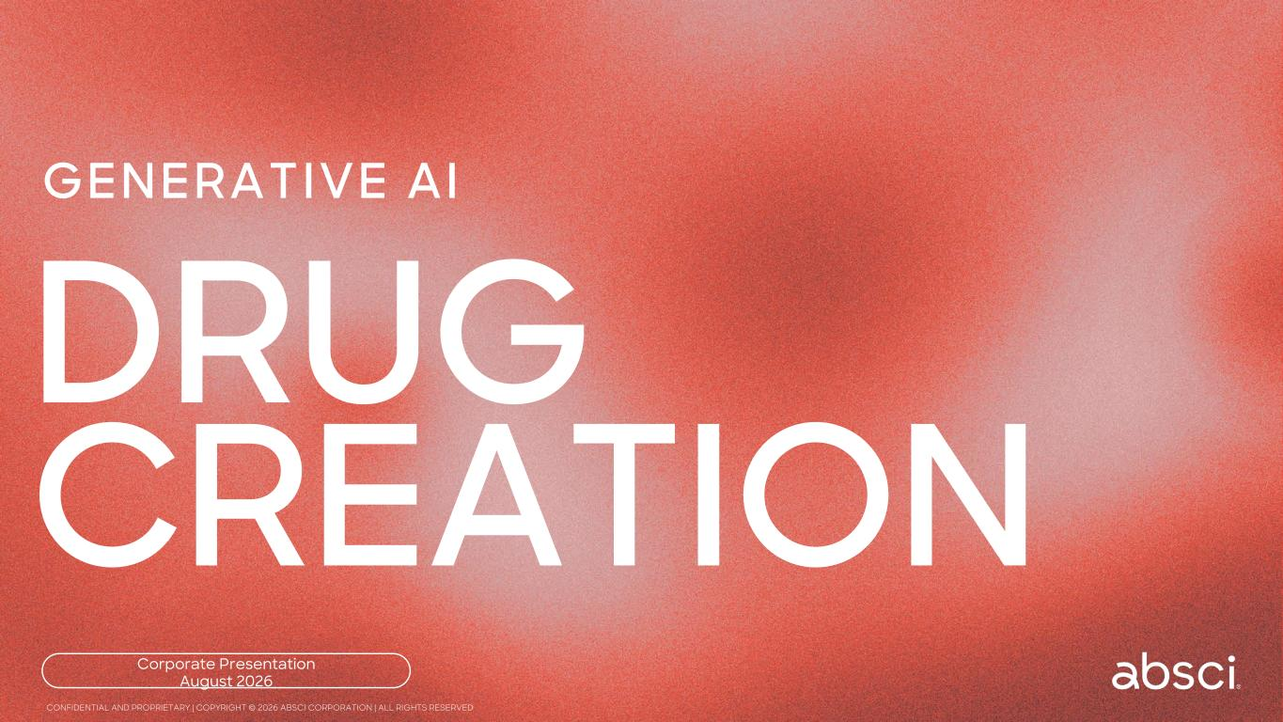

Corporate Presentation August 2026 GENERATIVE AI DRUG CREATION CONFIDENTIAL AND PROPRIETARY | COPYRIGHT © 2026 ABSCI CORPORATION | ALL RIGHTS RESERVED

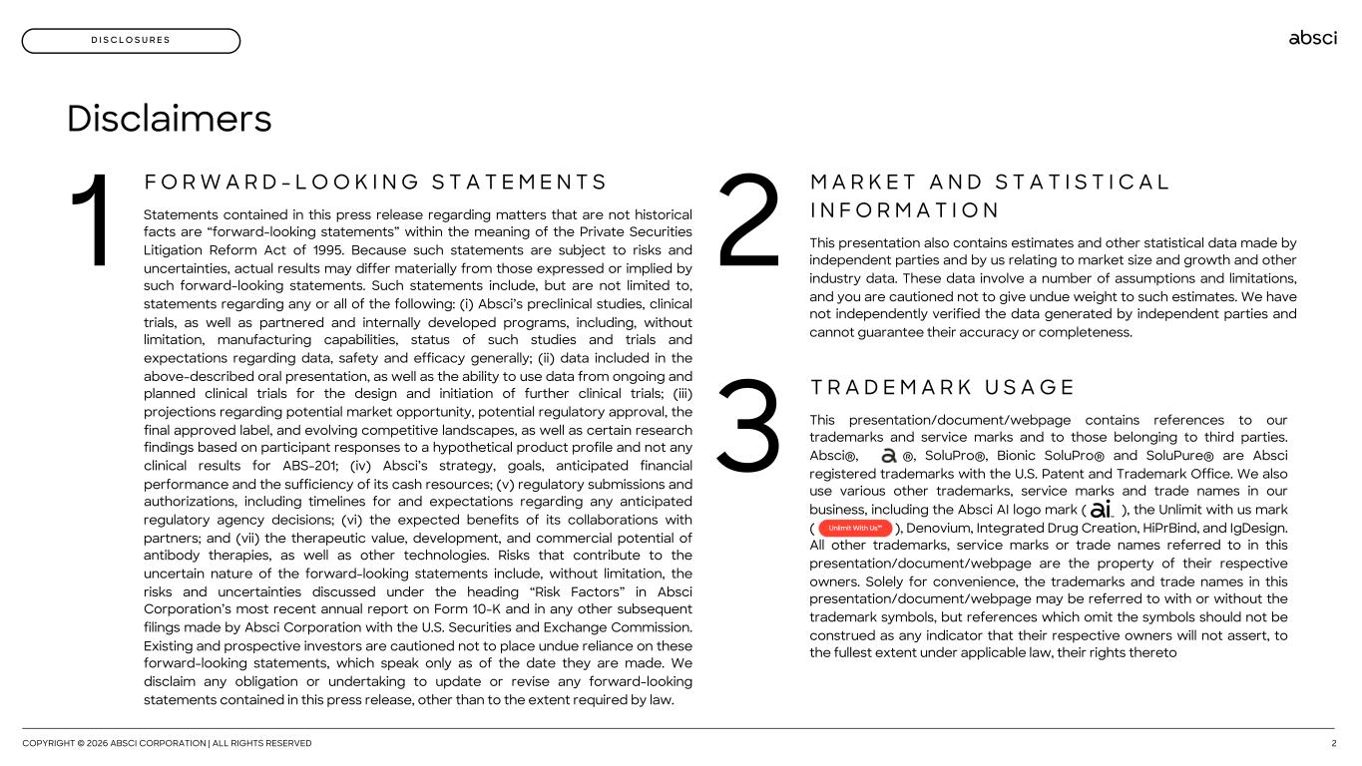
Disclaimers F O R W A R D - L O O K I N G S T A T E M E N T S Statements contained in this press release regarding matters that are not historical facts are “forward-looking statements” within the meaning of the Private Securities Litigation Reform Act of 1995. Because such statements are subject to risks and uncertainties, actual results may differ materially from those expressed or implied by such forward-looking statements. Such statements include, but are not limited to, statements regarding any or all of the following: (i) Absci’s preclinical studies, clinical trials, as well as partnered and internally developed programs, including, without limitation, manufacturing capabilities, status of such studies and trials and expectations regarding data, safety and efficacy generally; (ii) data included in the above-described oral presentation, as well as the ability to use data from ongoing and planned clinical trials for the design and initiation of further clinical trials; (iii) projections regarding potential market opportunity, potential regulatory approval, the final approved label, and evolving competitive landscapes, as well as certain research findings based on participant responses to a hypothetical product profile and not any clinical results for ABS-201; (iv) Absci’s strategy, goals, anticipated financial performance and the sufficiency of its cash resources; (v) regulatory submissions and authorizations, including timelines for and expectations regarding any anticipated regulatory agency decisions; (vi) the expected benefits of its collaborations with partners; and (vii) the therapeutic value, development, and commercial potential of antibody therapies, as well as other technologies. Risks that contribute to the uncertain nature of the forward-looking statements include, without limitation, the risks and uncertainties discussed under the heading “Risk Factors” in Absci Corporation’s most recent annual report on Form 10-K and in any other subsequent filings made by Absci Corporation with the U.S. Securities and Exchange Commission. Existing and prospective investors are cautioned not to place undue reliance on these forward-looking statements, which speak only as of the date they are made. We disclaim any obligation or undertaking to update or revise any forward-looking statements contained in this press release, other than to the extent required by law. 1 M A R K E T A N D S T A T I S T I C A L I N F O R M A T I O N This presentation also contains estimates and other statistical data made by independent parties and by us relating to market size and growth and other industry data. These data involve a number of assumptions and limitations, and you are cautioned not to give undue weight to such estimates. We have not independently verified the data generated by independent parties and cannot guarantee their accuracy or completeness. 2 T R A D E M A R K U S A G E This presentation/document/webpage contains references to our trademarks and service marks and to those belonging to third parties. Absci®, ®, SoluPro®, Bionic SoluPro® and SoluPure® are Absci registered trademarks with the U.S. Patent and Trademark Office. We also use various other trademarks, service marks and trade names in our business, including the Absci AI logo mark ( ), the Unlimit with us mark ( ), Denovium, Integrated Drug Creation, HiPrBind, and IgDesign. All other trademarks, service marks or trade names referred to in this presentation/document/webpage are the property of their respective owners. Solely for convenience, the trademarks and trade names in this presentation/document/webpage may be referred to with or without the trademark symbols, but references which omit the symbols should not be construed as any indicator that their respective owners will not assert, to the fullest extent under applicable law, their rights thereto 3 COPYRIGHT © 2026 ABSCI CORPORATION | ALL RIGHTS RESERVED 2 D I S C L O S U R E S

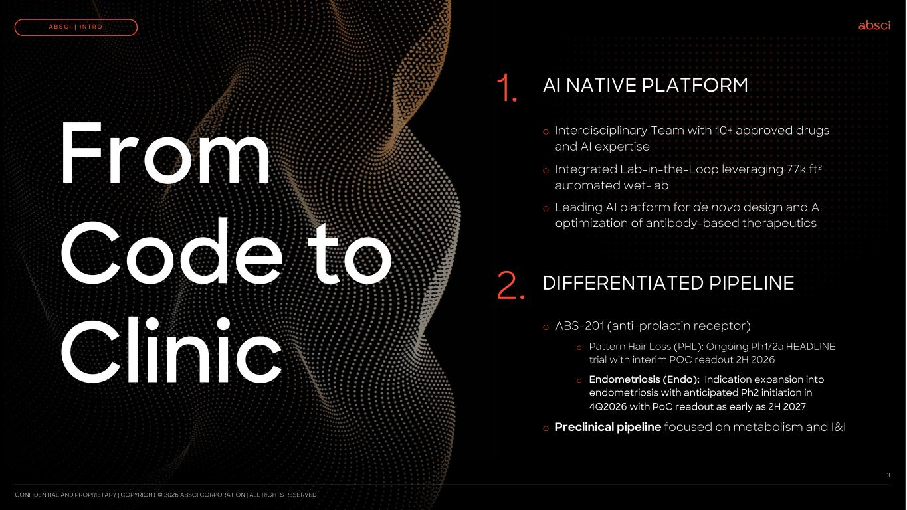
AI NATIVE PLATFORM1. DIFFERENTIATED PIPELINE2. From Code to Clinic CONFIDENTIAL AND PROPRIETARY | COPYRIGHT © 2026 ABSCI CORPORATION | ALL RIGHTS RESERVED 3 A B S C I | I N T R O o Interdisciplinary Team with 10+ approved drugs and AI expertise o Integrated Lab-in-the-Loop leveraging 77k ft² automated wet-lab o Leading AI platform for de novo design and AI optimization of antibody-based therapeutics o ABS-201 (anti-prolactin receptor) o Pattern Hair Loss (PHL): Ongoing Ph1/2a HEADLINE trial with interim POC readout 2H 2026 o Endometriosis (Endo): Indication expansion into endometriosis with anticipated Ph2 initiation in 4Q2026 with PoC readout as early as 2H 2027 o Preclinical pipeline focused on metabolism and I&I

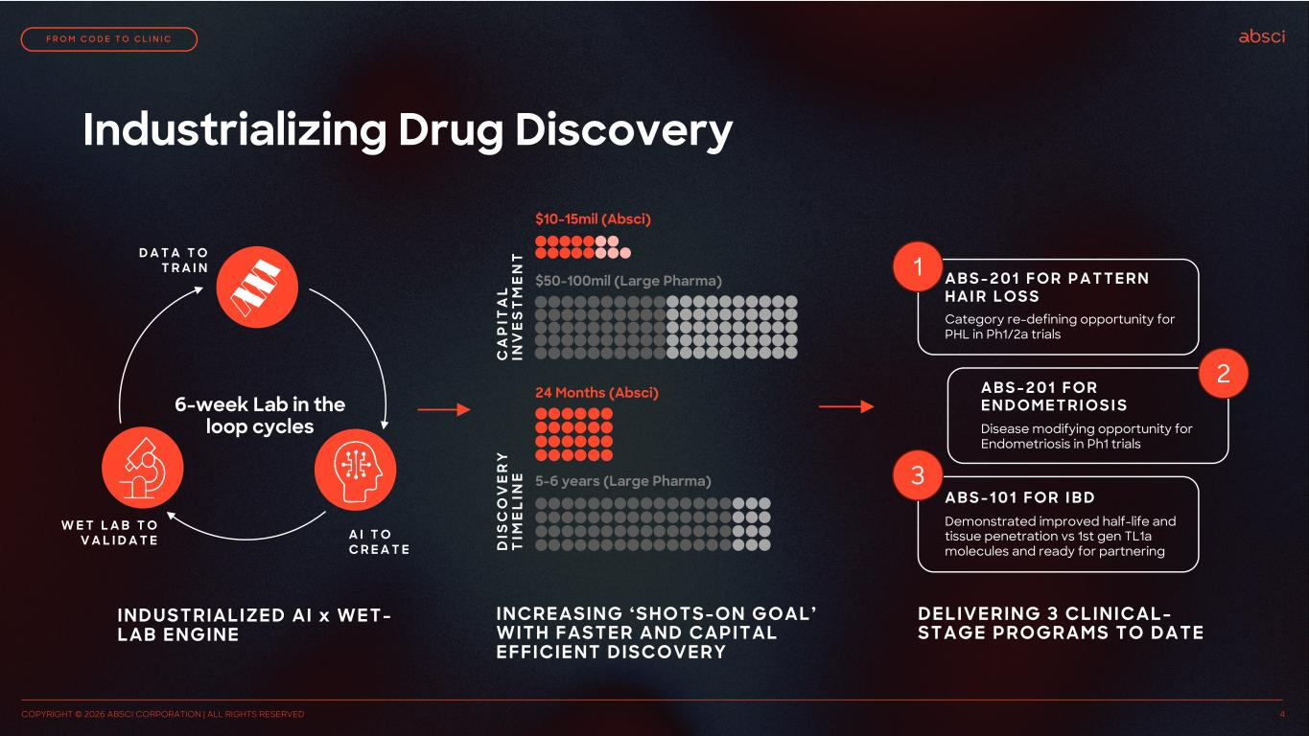
Industrializing Drug Discovery INCREASING ‘SHOTS-ON GOAL’ WITH FASTER AND CAPITAL EFFICIENT DISCOVERY $10-15mil (Absci) $50-100mil (Large Pharma) 24 Months (Absci) 5-6 years (Large Pharma) C A P IT A L IN V E S T M E N T D IS C O V E R Y T IM E L IN E DELIVERING 3 CLINICAL- STAGE PROGRAMS TO DATE 1 2 3 A B S - 2 0 1 FOR P A TTERN HA I R LOS S A B S - 2 0 1 FOR ENDOMETRI OS I S A B S - 1 0 1 FOR I B D Category re-defining opportunity for PHL in Ph1/2a trials Disease modifying opportunity for Endometriosis in Ph1 trials Demonstrated improved half-life and tissue penetration vs 1st gen TL1a molecules and ready for partnering COPYRIGHT © 2026 ABSCI CORPORATION | ALL RIGHTS RESERVED 4 F R O M C O D E T O C L I N I C INDUSTRIALIZED AI x WET- LAB ENGINE 6-week Lab in the loop cycles D A T A T O T R A I N W E T L A B T O V A L I D A T E A I T O C R E A T E

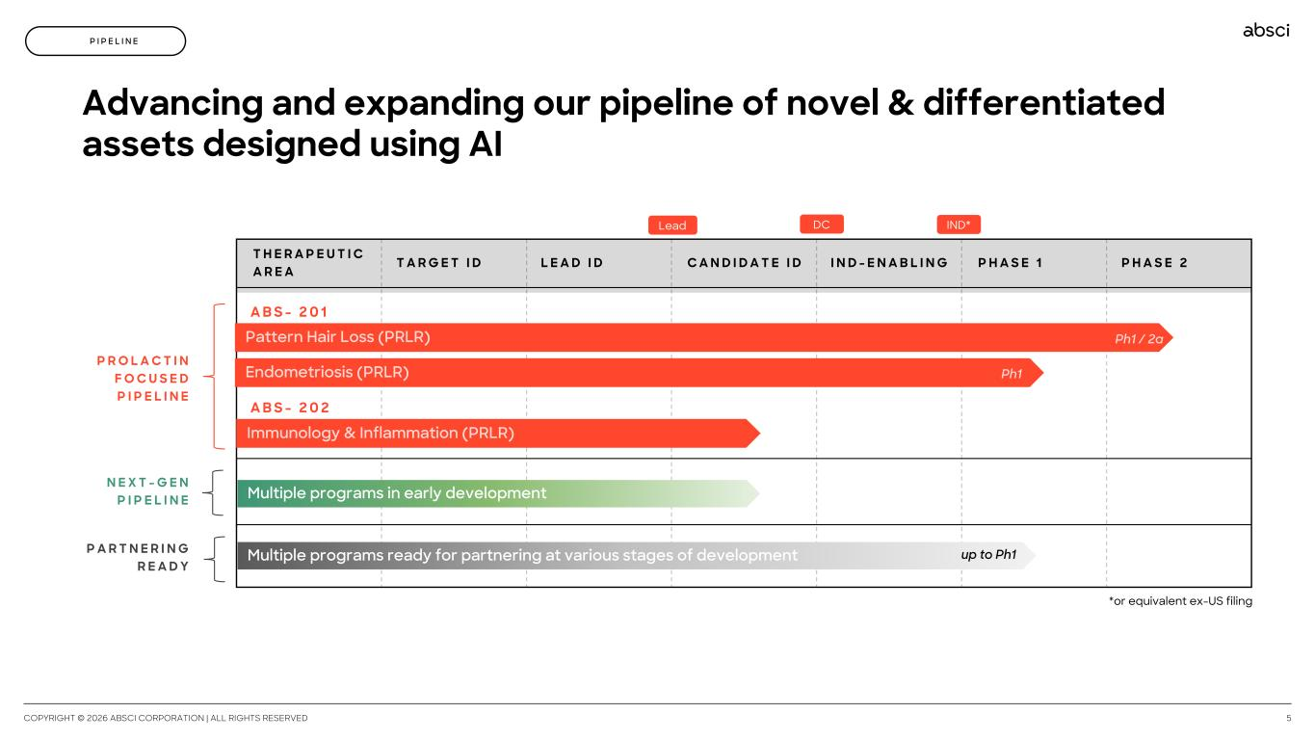
*or equivalent ex-US filing N E X T - G E N P I P E L I N E COPYRIGHT © 2026 ABSCI CORPORATION | ALL RIGHTS RESERVED 5 P I P E L I N E T H E R A P E U T I C A R E A T A R G E T I D L E A D I D C A N D I D A T E I D I N D - E N A B L I N G P H A S E 1 P H A S E 2 A B S - 2 0 1 Pattern Hair Loss (PRLR) Endometriosis (PRLR) A B S - 2 0 2 Immunology & Inflammation (PRLR) Ph1 IND*DCLead Ph1 / 2a Advancing and expanding our pipeline of novel & differentiated assets designed using AI Multiple programs ready for partnering at various stages of development P R O L A C T I N F O C U S E D P I P E L I N E P A R T N E R I N G R E A D Y Multiple programs in early development up to Ph1

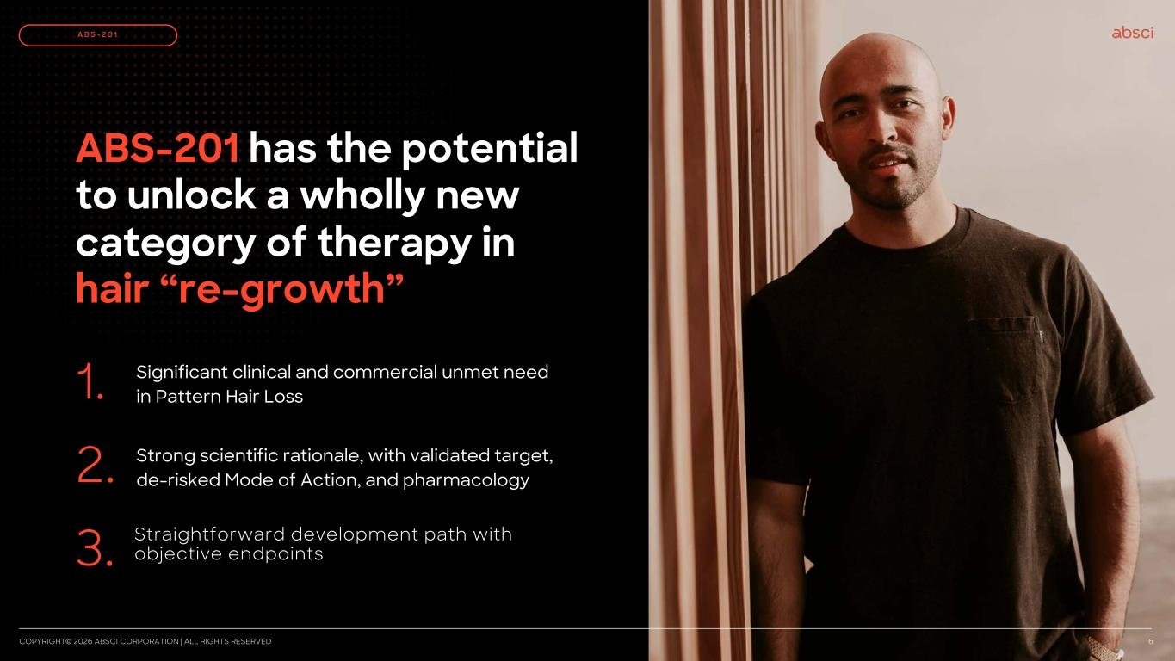
ABS-201 has the potential to unlock a wholly new category of therapy in hair “re-growth” Significant clinical and commercial unmet need in Pattern Hair Loss1. Strong scientific rationale, with validated target, de-risked Mode of Action, and pharmacology2. 3. COPYRIGHT© 2026 ABSCI CORPORATION | ALL RIGHTS RESERVED 6 A B S - 2 0 1 Straightforward development path with objective endpoints

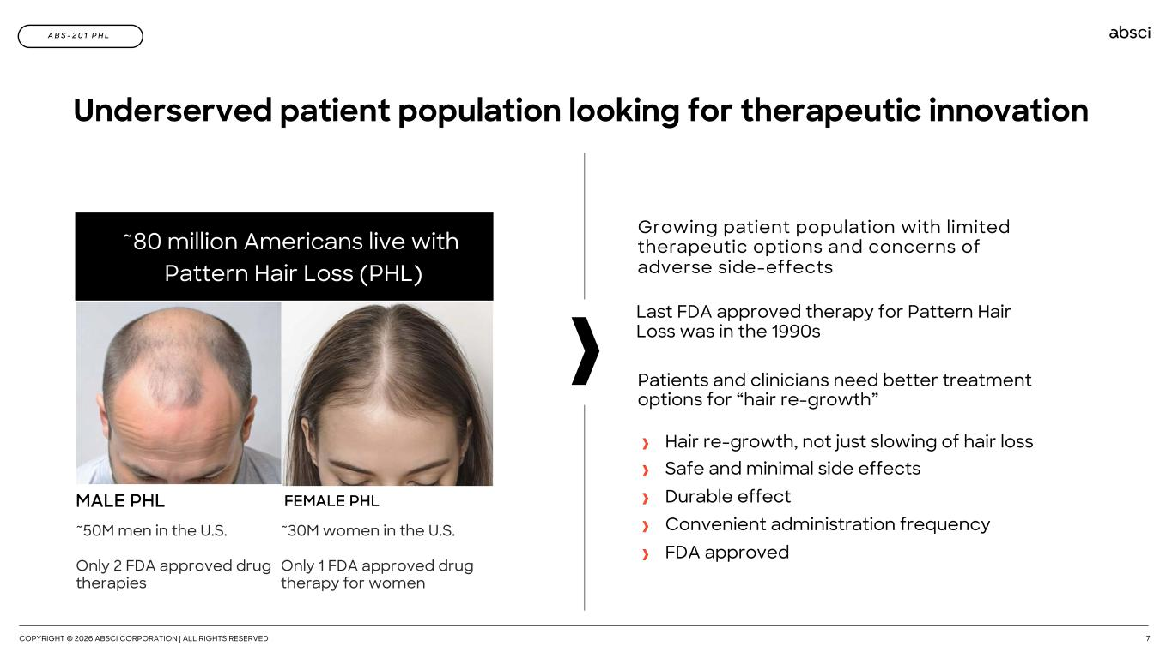
COPYRIGHT © 2026 ABSCI CORPORATION | ALL RIGHTS RESERVED 7 A B S - 2 0 1 P H L Underserved patient population looking for therapeutic innovation ~80 million Americans live with Pattern Hair Loss (PHL) FEMALE PHL ~30M women in the U.S. Only 1 FDA approved drug therapy for women ~50M men in the U.S. Only 2 FDA approved drug therapies MALE PHL Growing patient population with limited therapeutic options and concerns of adverse side-effects Last FDA approved therapy for Pattern Hair Loss was in the 1990s Patients and clinicians need better treatment options for “hair re-growth” Hair re-growth, not just slowing of hair loss Safe and minimal side effects Durable effect Convenient administration frequency FDA approved

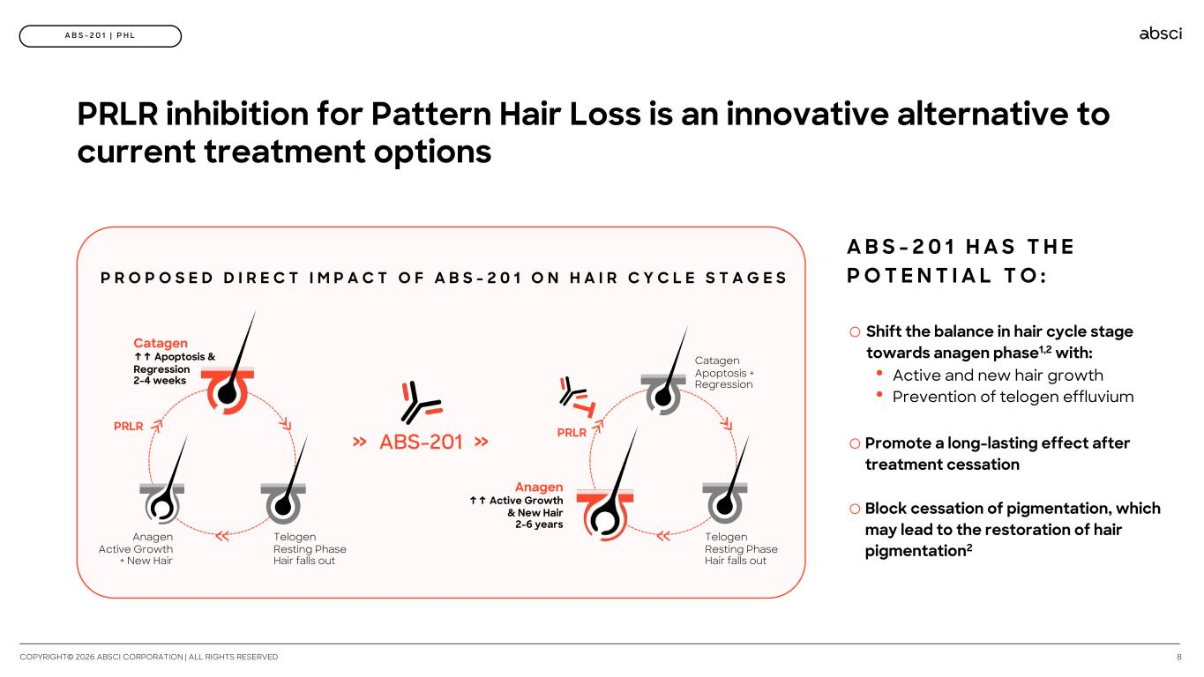
8 A B S - 2 0 1 | P H L PRLR inhibition for Pattern Hair Loss is an innovative alternative to current treatment options P R O P O S E D D I R E C T I M P A C T O F A B S - 2 0 1 O N H A I R C Y C L E S T A G E S Telogen Resting Phase Hair falls out Catagen ↑↑ Apoptosis & Regression 2-4 weeks Anagen Active Growth + New Hair » »»PRLR ABS-201 »» Anagen ↑↑ Active Growth & New Hair 2-6 years Catagen Apoptosis + Regression Telogen Resting Phase Hair falls out »» » PRLR o Shift the balance in hair cycle stage towards anagen phase1,2 with: • Active and new hair growth • Prevention of telogen effluvium o Promote a long-lasting effect after treatment cessation o Block cessation of pigmentation, which may lead to the restoration of hair pigmentation2 A B S - 2 0 1 H A S T H E P O T E N T I A L T O : COPYRIGHT© 2026 ABSCI CORPORATION | ALL RIGHTS RESERVED

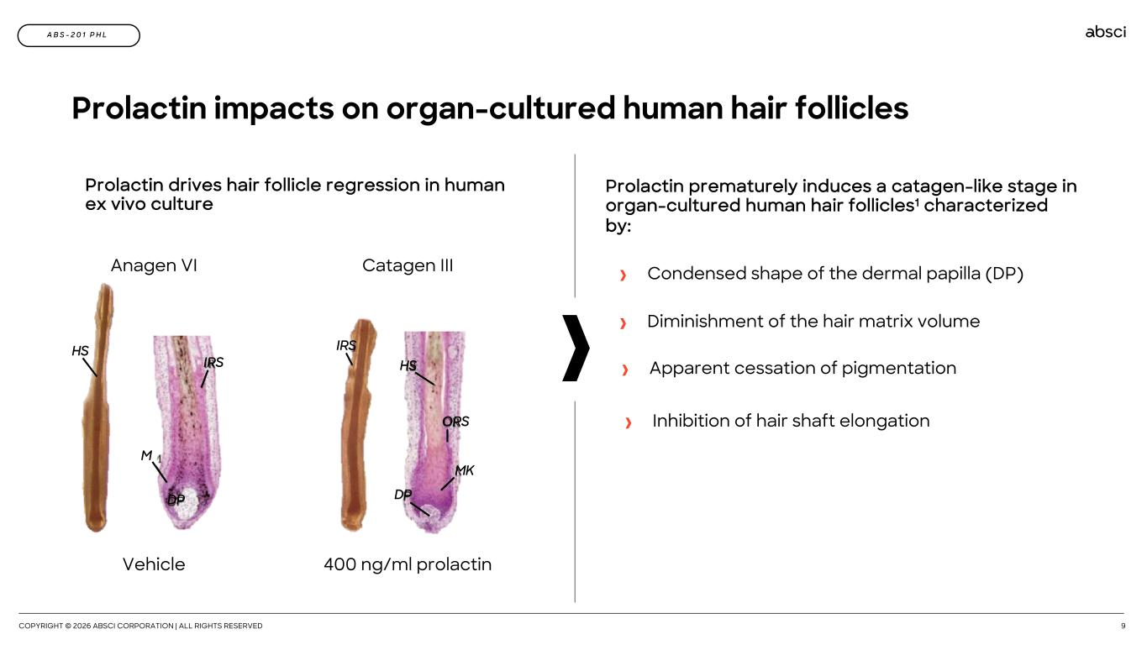
COPYRIGHT © 2026 ABSCI CORPORATION | ALL RIGHTS RESERVED 9 A B S - 2 0 1 P H L Prolactin impacts on organ-cultured human hair follicles Prolactin prematurely induces a catagen-like stage in organ-cultured human hair follicles1 characterized by: Vehicle 400 ng/ml prolactin Catagen IIIAnagen VI HS M DP IRS IRS HS ORS DP MK Apparent cessation of pigmentation Condensed shape of the dermal papilla (DP) Diminishment of the hair matrix volume Inhibition of hair shaft elongation Prolactin drives hair follicle regression in human ex vivo culture

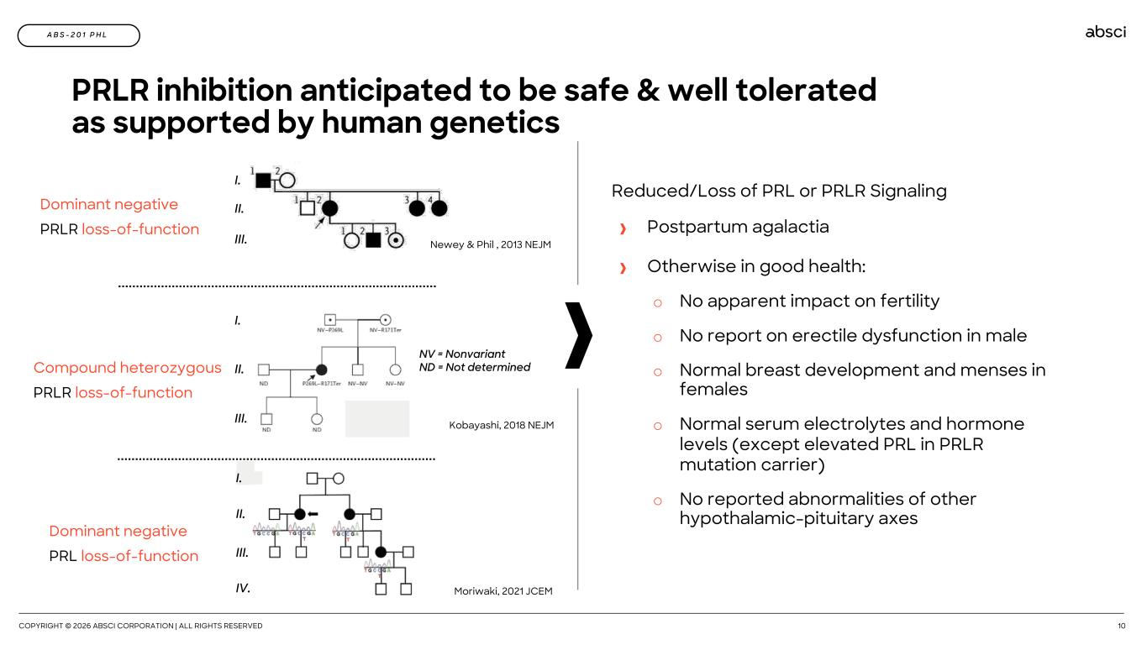
COPYRIGHT © 2026 ABSCI CORPORATION | ALL RIGHTS RESERVED 10 A B S - 2 0 1 P H L PRLR inhibition anticipated to be safe & well tolerated as supported by human genetics I. II. III. NV = Nonvariant ND = Not determined I. II. III. I. II. III. IV. Kobayashi, 2018 NEJM Moriwaki, 2021 JCEM Newey & Phil , 2013 NEJM Compound heterozygous PRLR loss-of-function Dominant negative PRL loss-of-function Dominant negative PRLR loss-of-function Reduced/Loss of PRL or PRLR Signaling Postpartum agalactia Otherwise in good health: o No apparent impact on fertility o No report on erectile dysfunction in male o Normal breast development and menses in females o Normal serum electrolytes and hormone levels (except elevated PRL in PRLR mutation carrier) o No reported abnormalities of other hypothalamic-pituitary axes

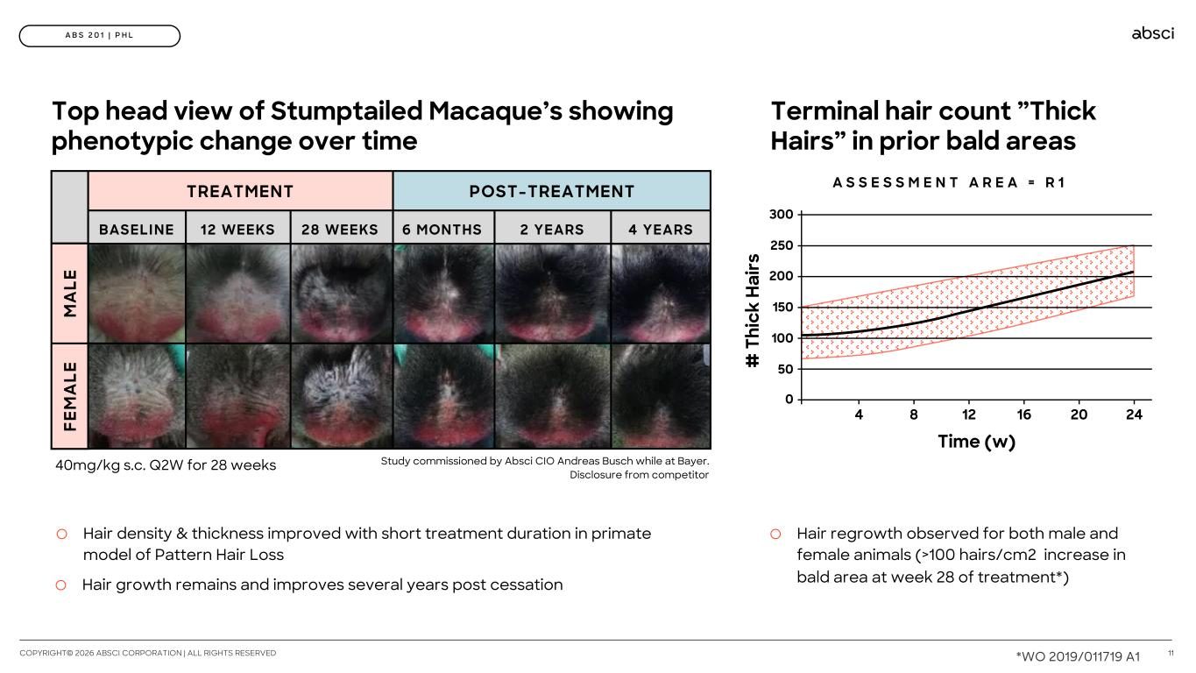
11 A B S 2 0 1 | P H L Terminal hair count ”Thick Hairs” in prior bald areas o Hair regrowth observed for both male and female animals (>100 hairs/cm2 increase in bald area at week 28 of treatment*) # T hi ck H ai rs Time (w) 200 100 0 250 150 50 300 4 8 12 16 20 24 A S S E S S M E N T A R E A = R 1TREATMENT POST-TREATMENT 12 WEEKSBASELINE 28 WEEKS 6 MONTHS 2 YEARS 4 YEARS FE M A LE M A LE Top head view of Stumptailed Macaque’s showing phenotypic change over time o Hair density & thickness improved with short treatment duration in primate model of Pattern Hair Loss o Hair growth remains and improves several years post cessation 40mg/kg s.c. Q2W for 28 weeks Study commissioned by Absci CIO Andreas Busch while at Bayer. Disclosure from competitor COPYRIGHT© 2026 ABSCI CORPORATION | ALL RIGHTS RESERVED *WO 2019/011719 A1

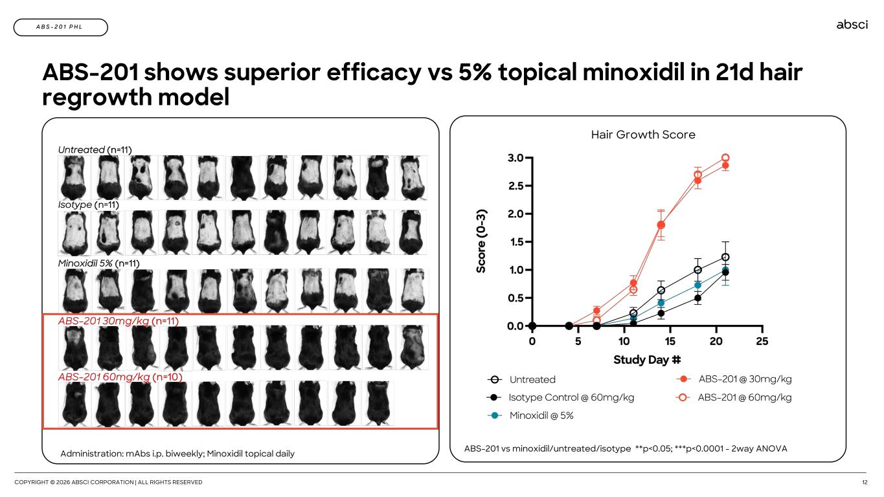
COPYRIGHT © 2026 ABSCI CORPORATION | ALL RIGHTS RESERVED 12 A B S - 2 0 1 P H L ABS-201 shows superior efficacy vs 5% topical minoxidil in 21d hair regrowth model Administration: mAbs i.p. biweekly; Minoxidil topical daily ABS-201 vs minoxidil/untreated/isotype **p<0.05; ***p<0.0001 - 2way ANOVA Hair Growth Score

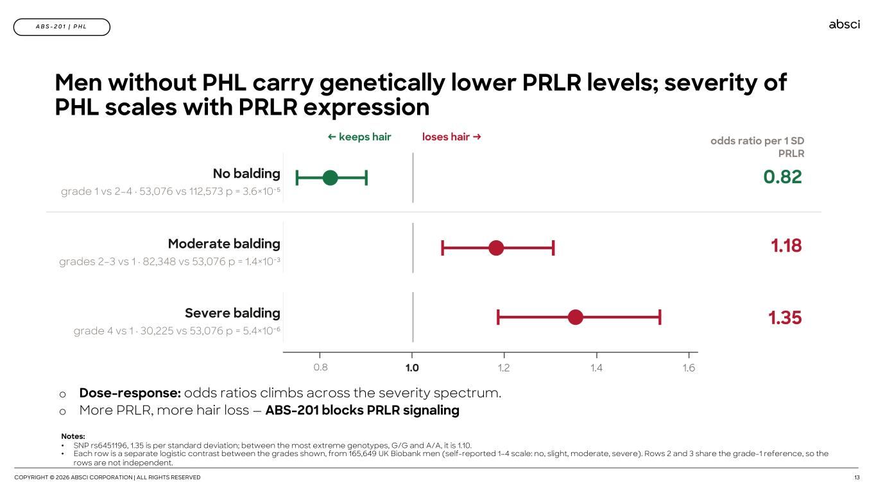
COPYRIGHT © 2026 ABSCI CORPORATION | ALL RIGHTS RESERVED 13 A B S - 2 0 1 | P H L Men without PHL carry genetically lower PRLR levels; severity of PHL scales with PRLR expression Notes: • SNP rs6451196, 1.35 is per standard deviation; between the most extreme genotypes, G/G and A/A, it is 1.10. • Each row is a separate logistic contrast between the grades shown, from 165,649 UK Biobank men (self-reported 1–4 scale: no, slight, moderate, severe). Rows 2 and 3 share the grade-1 reference, so the rows are not independent. ← keeps hair loses hair → No balding grade 1 vs 2–4 · 53,076 vs 112,573 p = 3.6×10⁻⁵ 0.82 Moderate balding grades 2–3 vs 1 · 82,348 vs 53,076 p = 1.4×10⁻³ 1.18 Severe balding grade 4 vs 1 · 30,225 vs 53,076 p = 5.4×10⁻⁶ 1.35 0.8 1.0 1.2 1.4 1.6 o Dose-response: odds ratios climbs across the severity spectrum. o More PRLR, more hair loss — ABS-201 blocks PRLR signaling odds ratio per 1 SD PRLR

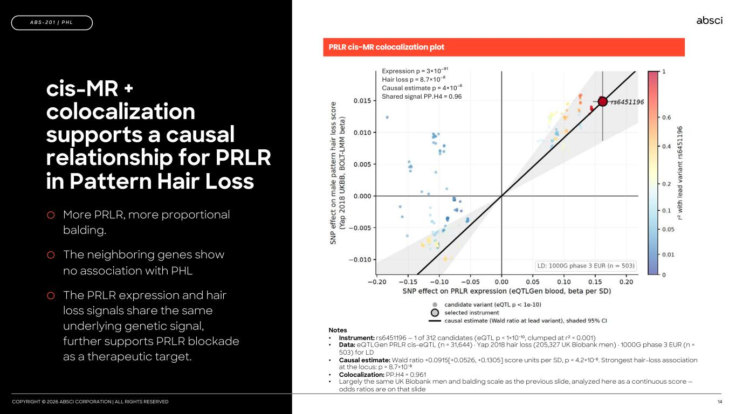
COPYRIGHT © 2026 ABSCI CORPORATION | ALL RIGHTS RESERVED 14 cis-MR + colocalization supports a causal relationship for PRLR in Pattern Hair Loss A B S - 2 0 1 | P H L o More PRLR, more proportional balding. o The neighboring genes show no association with PHL o The PRLR expression and hair loss signals share the same underlying genetic signal, further supports PRLR blockade as a therapeutic target. PRLR cis-MR colocalization plot Expression p = 3×10⁻⁹¹ Hair loss p = 8.7×10⁻⁸ Causal estimate p = 4×10⁻⁶ Shared signal PP.H4 = 0.96 Notes • Instrument: rs6451196 — 1 of 312 candidates (eQTL p < 1×10⁻¹⁰, clumped at r² < 0.001) • Data: eQTLGen PRLR cis-eQTL (n = 31,644) · Yap 2018 hair loss (205,327 UK Biobank men) · 1000G phase 3 EUR (n = 503) for LD • Causal estimate: Wald ratio +0.0915[+0.0526, +0.1305] score units per SD, p = 4.2×10⁻⁶. Strongest hair-loss association at the locus: p = 8.7×10⁻⁸ • Colocalization: PP.H4 = 0.961 • Largely the same UK Biobank men and balding scale as the previous slide, analyzed here as a continuous score — odds ratios are on that slide

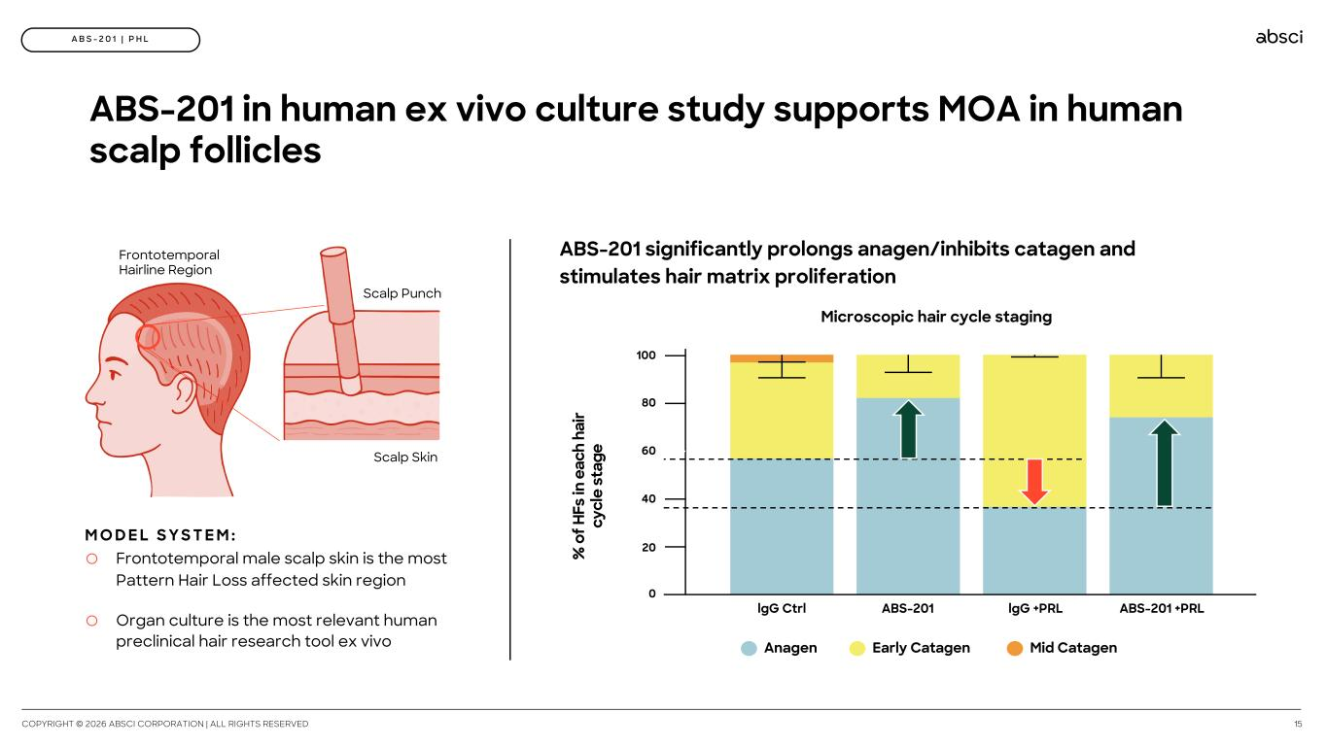
COPYRIGHT © 2026 ABSCI CORPORATION | ALL RIGHTS RESERVED 15 A B S - 2 0 1 | P H L ABS-201 in human ex vivo culture study supports MOA in human scalp follicles ABS-201 significantly prolongs anagen/inhibits catagen and stimulates hair matrix proliferation Anagen Early Catagen Mid Catagen lgG Ctrl ABS-201 lgG +PRL ABS-201 +PRL 80 40 0 100 60 20 Frontotemporal Hairline Region Scalp Punch Scalp Skin o Frontotemporal male scalp skin is the most Pattern Hair Loss affected skin region o Organ culture is the most relevant human preclinical hair research tool ex vivo M O D E L S Y S T E M : Microscopic hair cycle staging % o f H Fs in e ac h ha ir cy cl e st ag e

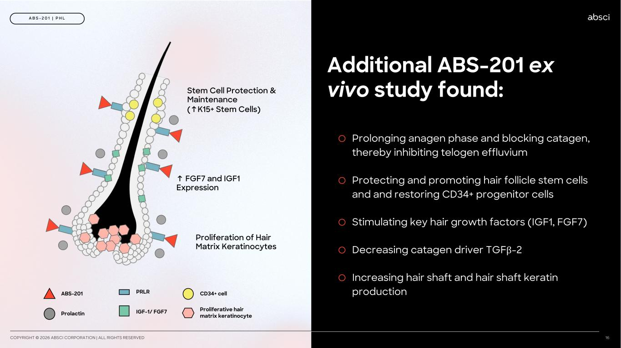
COPYRIGHT © 2026 ABSCI CORPORATION | ALL RIGHTS RESERVED 16 A B S - 2 0 1 | P H L Additional ABS-201 ex vivo study found: o Prolonging anagen phase and blocking catagen, thereby inhibiting telogen effluvium o Protecting and promoting hair follicle stem cells and and restoring CD34+ progenitor cells o Stimulating key hair growth factors (IGF1, FGF7) o Decreasing catagen driver TGFβ-2 o Increasing hair shaft and hair shaft keratin production IGF-1/ FGF7 PRLRABS-201 CD34+ cell Proliferative hair matrix keratinocyteProlactin Stem Cell Protection & Maintenance (↑K15+ Stem Cells) ↑ FGF7 and IGF1 Expression Proliferation of Hair Matrix Keratinocytes

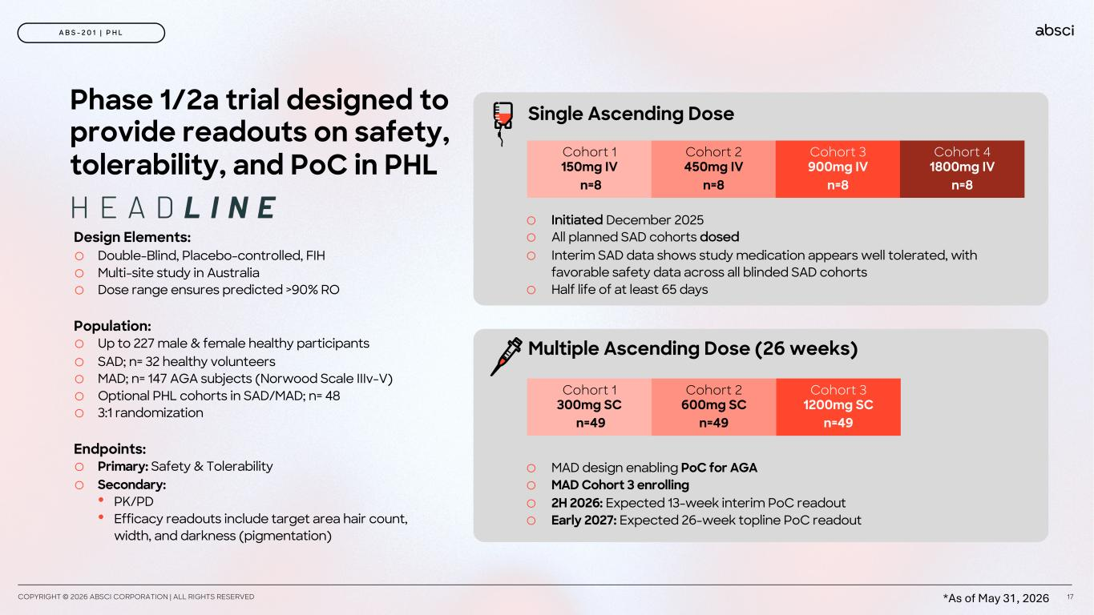
Phase 1/2a trial designed to provide readouts on safety, tolerability, and PoC in PHL Design Elements: o Double-Blind, Placebo-controlled, FIH o Multi-site study in Australia o Dose range ensures predicted >90% RO Population: o Up to 227 male & female healthy participants o SAD; n= 32 healthy volunteers o MAD; n= 147 AGA subjects (Norwood Scale IIIv-V) o Optional PHL cohorts in SAD/MAD; n= 48 o 3:1 randomization Endpoints: o Primary: Safety & Tolerability o Secondary: • PK/PD • Efficacy readouts include target area hair count, width, and darkness (pigmentation) COPYRIGHT © 2026 ABSCI CORPORATION | ALL RIGHTS RESERVED 17 A B S - 2 0 1 | P H L Single Ascending Dose Cohort 1 150mg IV n=8 Cohort 2 450mg IV n=8 Cohort 3 900mg IV n=8 Cohort 4 1800mg IV n=8 Cohort 1 300mg SC n=49 Cohort 2 600mg SC n=49 Cohort 3 1200mg SC n=49 Multiple Ascending Dose (26 weeks) o Initiated December 2025 o All planned SAD cohorts dosed o Interim SAD data shows study medication appears well tolerated, with favorable safety data across all blinded SAD cohorts o Half life of at least 65 days o MAD design enabling PoC for AGA o MAD Cohort 3 enrolling o 2H 2026: Expected 13-week interim PoC readout o Early 2027: Expected 26-week topline PoC readout *As of May 31, 2026

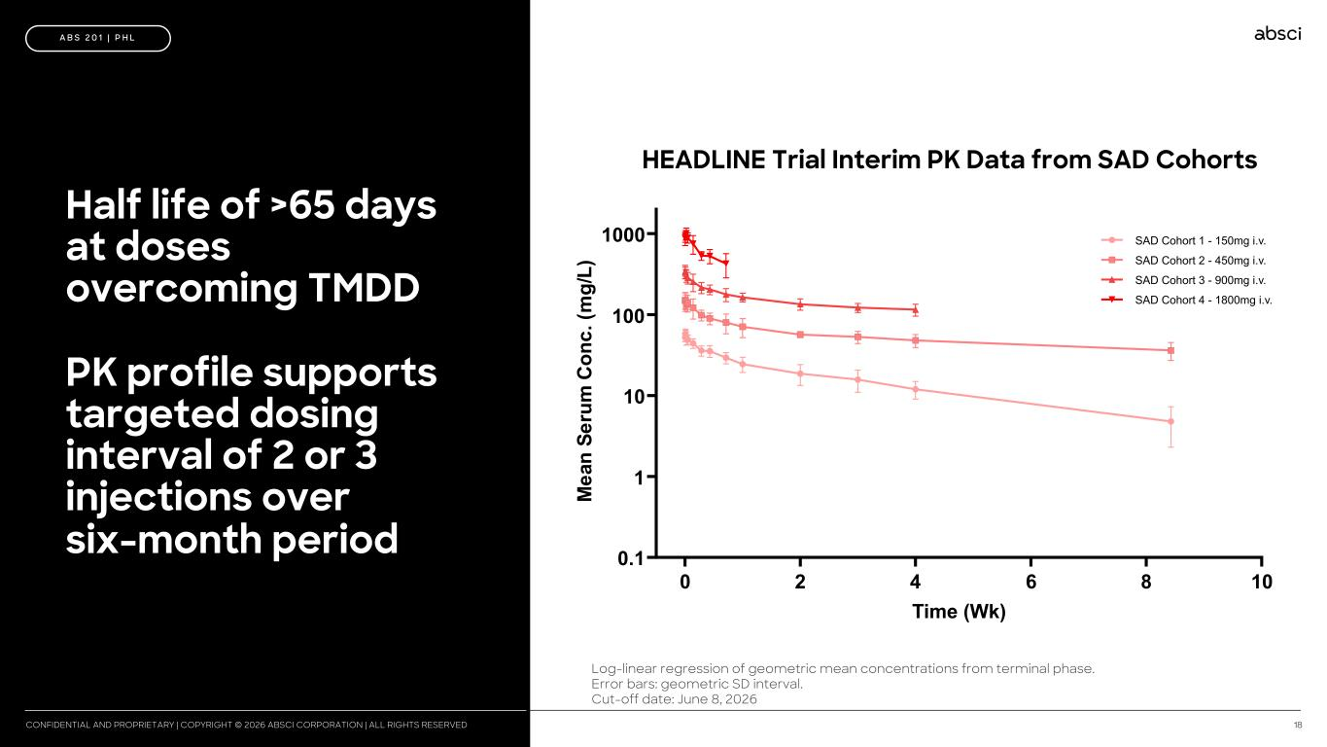
18CONFIDENTIAL AND PROPRIETARY | COPYRIGHT © 2026 ABSCI CORPORATION | ALL RIGHTS RESERVED Half life of >65 days at doses overcoming TMDD PK profile supports targeted dosing interval of 2 or 3 injections over six-month period A B S 2 0 1 | P H L 0 2 4 6 8 10 0.1 1 10 100 1000 Time (Wk) M ea n Se ru m C on c. (m g/ L) SAD Cohort 1 - 150mg i.v. SAD Cohort 2 - 450mg i.v. SAD Cohort 3 - 900mg i.v. SAD Cohort 4 - 1800mg i.v. Log-linear regression of geometric mean concentrations from terminal phase. Error bars: geometric SD interval. Cut-off date: June 8, 2026 HEADLINE Trial Interim PK Data from SAD Cohorts

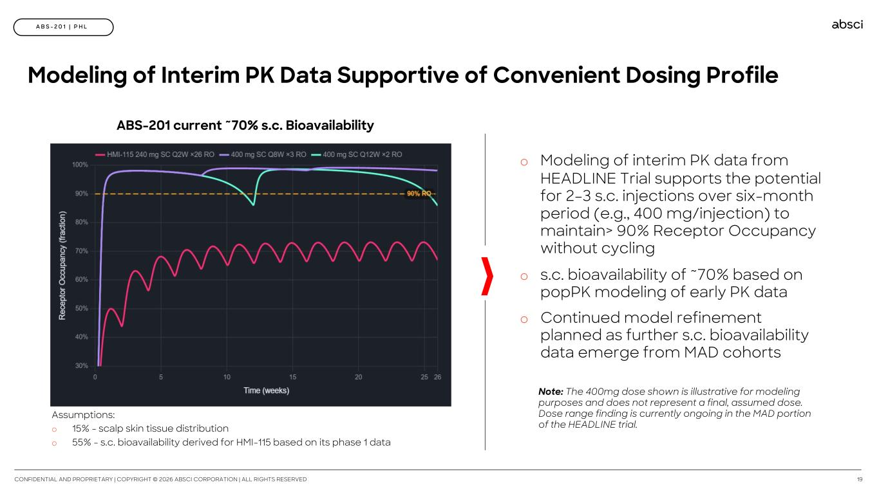
CONFIDENTIAL AND PROPRIETARY | COPYRIGHT © 2026 ABSCI CORPORATION | ALL RIGHTS RESERVED 19 A B S - 2 0 1 | P H L o Modeling of interim PK data from HEADLINE Trial supports the potential for 2–3 s.c. injections over six-month period (e.g., 400 mg/injection) to maintain> 90% Receptor Occupancy without cycling o s.c. bioavailability of ~70% based on popPK modeling of early PK data o Continued model refinement planned as further s.c. bioavailability data emerge from MAD cohorts Assumptions: o 15% - scalp skin tissue distribution o 55% - s.c. bioavailability derived for HMI-115 based on its phase 1 data Modeling of Interim PK Data Supportive of Convenient Dosing Profile ABS-201 current ~70% s.c. Bioavailability Note: The 400mg dose shown is illustrative for modeling purposes and does not represent a final, assumed dose. Dose range finding is currently ongoing in the MAD portion of the HEADLINE trial.

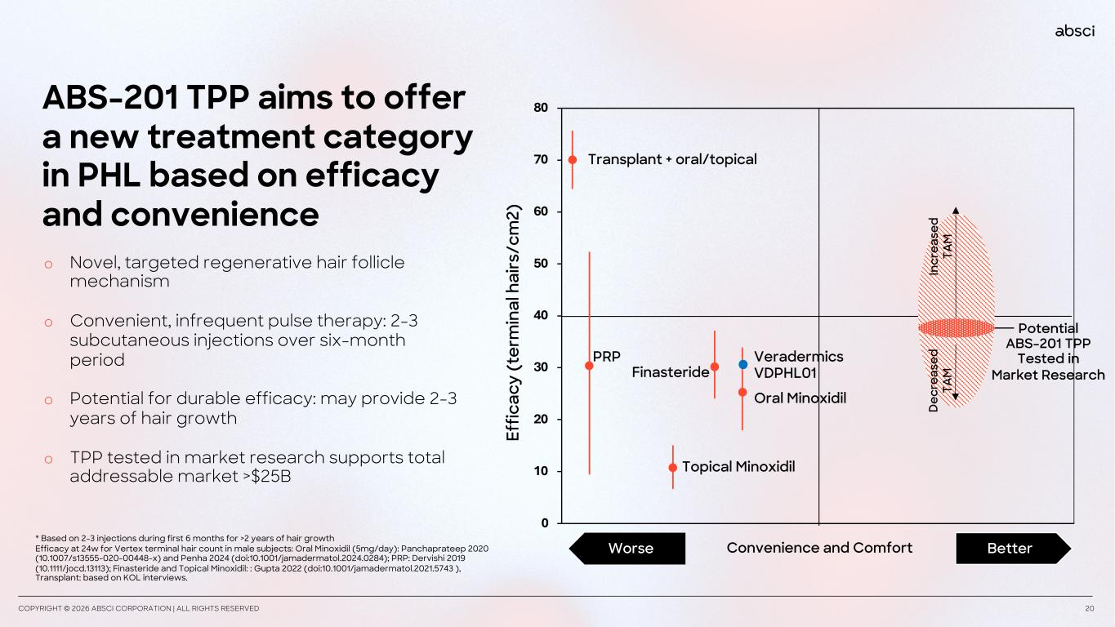
A B S - 2 0 1 | P H L COPYRIGHT © 2026 ABSCI CORPORATION | ALL RIGHTS RESERVED 20 ABS-201 TPP aims to offer a new treatment category in PHL based on efficacy and convenience 0 10 20 30 40 50 60 70 80 Ef fic ac y (t er m in al h ai rs /c m 2) Topical Minoxidil Oral Minoxidil Finasteride PRP Transplant + oral/topical * Based on 2-3 injections during first 6 months for >2 years of hair growth Efficacy at 24w for Vertex terminal hair count in male subjects: Oral Minoxidil (5mg/day): Panchaprateep 2020 (10.1007/s13555-020-00448-x) and Penha 2024 (doi:10.1001/jamadermatol.2024.0284); PRP: Dervishi 2019 (10.1111/jocd.13113); Finasteride and Topical Minoxidil: : Gupta 2022 (doi:10.1001/jamadermatol.2021.5743 ), Transplant: based on KOL interviews. Convenience and Comfort BetterWorse Veradermics VDPHL01 In cr ea se d TA M D ec re as ed TA M o Novel, targeted regenerative hair follicle mechanism o Convenient, infrequent pulse therapy: 2-3 subcutaneous injections over six-month period o Potential for durable efficacy: may provide 2-3 years of hair growth o TPP tested in market research supports total addressable market >$25B Potential ABS-201 TPP Tested in Market Research

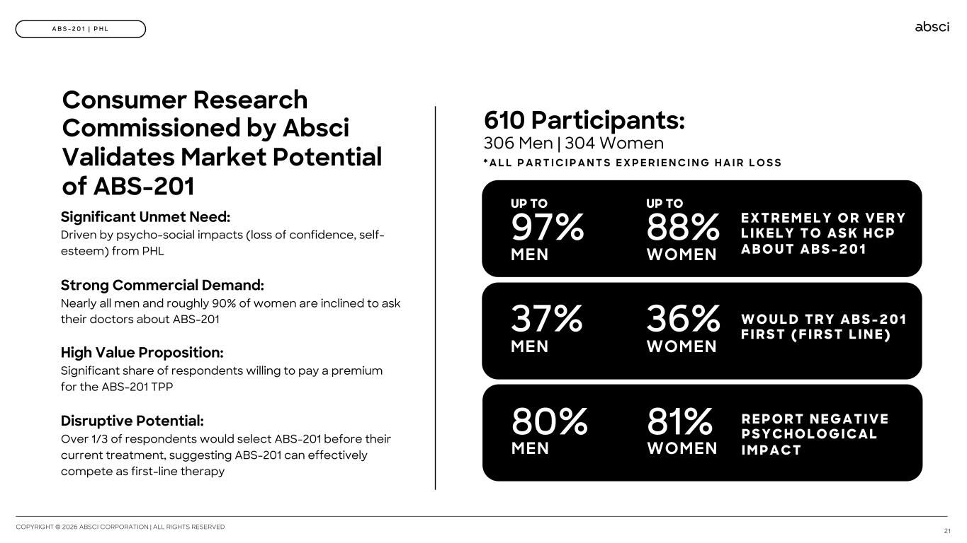
Consumer Research Commissioned by Absci Validates Market Potential of ABS-201 Significant Unmet Need: Driven by psycho-social impacts (loss of confidence, self- esteem) from PHL Strong Commercial Demand: Nearly all men and roughly 90% of women are inclined to ask their doctors about ABS-201 High Value Proposition: Significant share of respondents willing to pay a premium for the ABS-201 TPP Disruptive Potential: Over 1/3 of respondents would select ABS-201 before their current treatment, suggesting ABS-201 can effectively compete as first-line therapy 610 Participants: 306 Men | 304 Women COPYRIGHT © 2026 ABSCI CORPORATION | ALL RIGHTS RESERVED 21 A B S - 2 0 1 | P H L * A L L P A R T I C I P A N T S E X P E R I E N C I N G H A I R L O S S R E P O R T N E G A T I V E P S Y C H O L O G I C A L I M P A C T 80% MEN 81% WOMEN W O U L D T R Y A B S - 2 0 1 F I R S T ( F I R S T L I N E )37% MEN 36% WOMEN E X T R E M E L Y O R V E R Y L I K E L Y T O A S K H C P A B O U T A B S - 2 0 1 UP TO 97% MEN WOMEN UP TO 88%

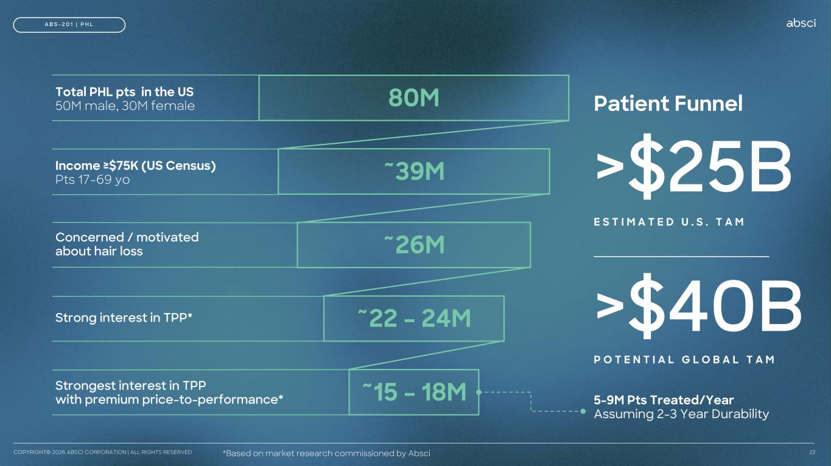
5-9M Pts Treated/Year Assuming 2-3 Year Durability Patient Funnel >$25B E S T I M A T E D U . S . T A M >$40B P O T E N T I A L G L O B A L T A M Total PHL pts in the US 50M male, 30M female Income ≥$75K (US Census) Pts 17-69 yo Concerned / motivated about hair loss Strong interest in TPP* Strongest interest in TPP with premium price-to-performance* COPYRIGHT© 2026 ABSCI CORPORATION | ALL RIGHTS RESERVED 22 A B S - 2 0 1 | P H L 80M ~39M ~26M ~22 – 24M ~15 – 18M *Based on market research commissioned by Absci

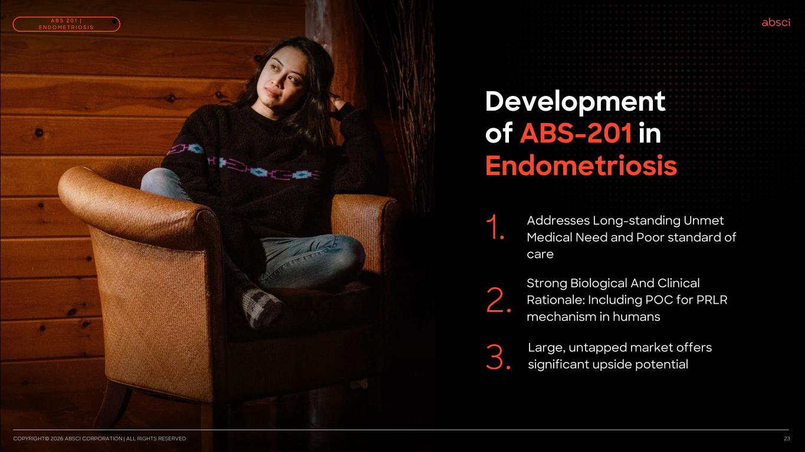
Development of ABS-201 in Endometriosis Addresses Long-standing Unmet Medical Need and Poor standard of care 1. Large, untapped market offers significant upside potential 2. Strong Biological And Clinical Rationale: Including POC for PRLR mechanism in humans 3. COPYRIGHT© 2026 ABSCI CORPORATION | ALL RIGHTS RESERVED 23 A B S 2 0 1 | E N D O M E T R I O S I S

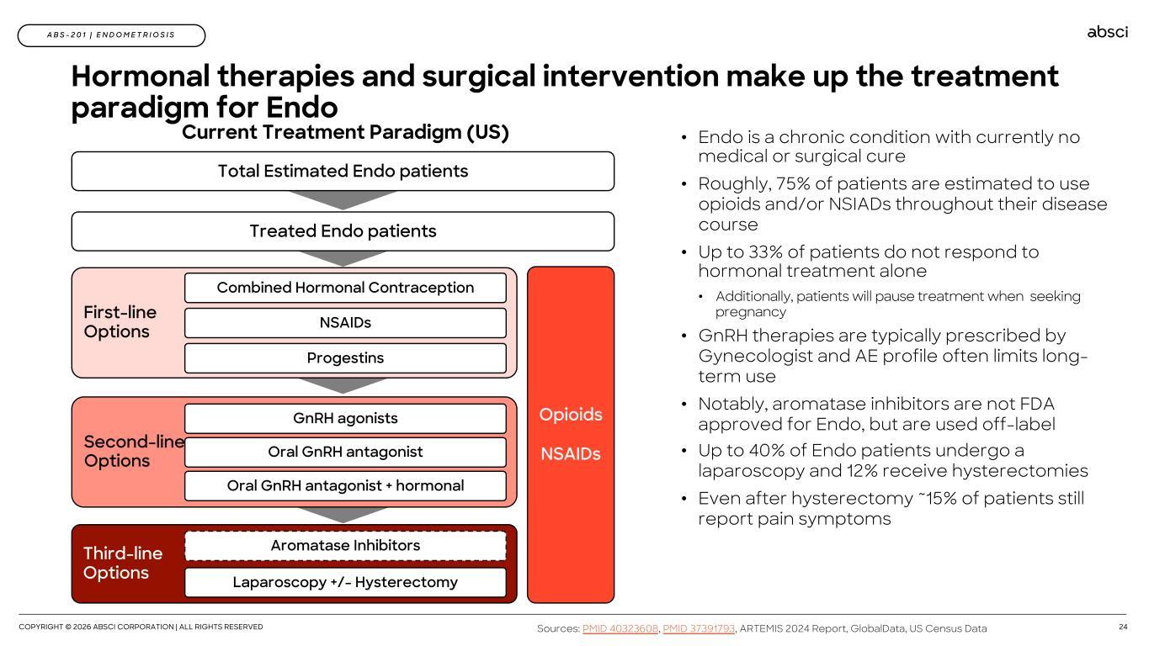
COPYRIGHT © 2026 ABSCI CORPORATION | ALL RIGHTS RESERVED 24 A B S - 2 0 1 | E N D O M E T R I O S I S Hormonal therapies and surgical intervention make up the treatment paradigm for Endo • Endo is a chronic condition with currently no medical or surgical cure • Roughly, 75% of patients are estimated to use opioids and/or NSIADs throughout their disease course • Up to 33% of patients do not respond to hormonal treatment alone • Additionally, patients will pause treatment when seeking pregnancy • GnRH therapies are typically prescribed by Gynecologist and AE profile often limits long- term use • Notably, aromatase inhibitors are not FDA approved for Endo, but are used off-label • Up to 40% of Endo patients undergo a laparoscopy and 12% receive hysterectomies • Even after hysterectomy ~15% of patients still report pain symptoms Sources: PMID 40323608, PMID 37391793, ARTEMIS 2024 Report, GlobalData, US Census Data Current Treatment Paradigm (US) Treated Endo patients First-line Options Combined Hormonal Contraception NSAIDs Progestins Second-line Options GnRH agonists Oral GnRH antagonist Oral GnRH antagonist + hormonal Total Estimated Endo patients Opioids NSAIDs Third-line Options Aromatase Inhibitors Laparoscopy +/- Hysterectomy

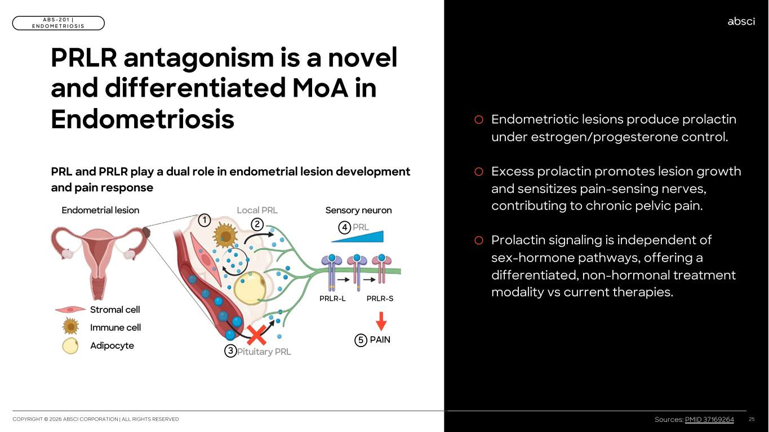
o Endometriotic lesions produce prolactin under estrogen/progesterone control. o Excess prolactin promotes lesion growth and sensitizes pain-sensing nerves, contributing to chronic pelvic pain. o Prolactin signaling is independent of sex-hormone pathways, offering a differentiated, non-hormonal treatment modality vs current therapies. COPYRIGHT © 2026 ABSCI CORPORATION | ALL RIGHTS RESERVED 25 A B S - 2 0 1 | E N D O M E T R I O S I S PRLR antagonism is a novel and differentiated MoA in Endometriosis PRL and PRLR play a dual role in endometrial lesion development and pain response Stromal cell Immune cell Adipocyte PRL 1 2 Endometrial lesion Local PRL PRLR-L PRLR-S Sensory neuron PAIN Pituitary PRL3 5 4 Sources: PMID 37169264

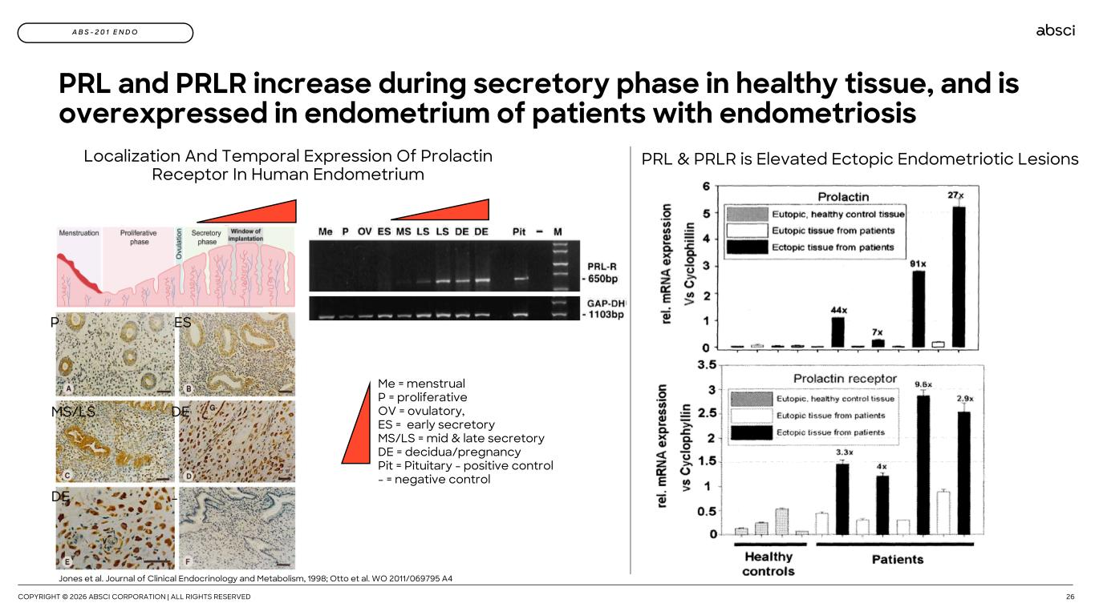
COPYRIGHT © 2026 ABSCI CORPORATION | ALL RIGHTS RESERVED 26 A B S - 2 0 1 E N D O Localization And Temporal Expression Of Prolactin Receptor In Human Endometrium PRL and PRLR increase during secretory phase in healthy tissue, and is overexpressed in endometrium of patients with endometriosis Me = menstrual P = proliferative OV = ovulatory, ES = early secretory MS/LS = mid & late secretory DE = decidua/pregnancy Pit = Pituitary - positive control - = negative control P ES MS/LS DE DE - PRL & PRLR is Elevated Ectopic Endometriotic Lesions Jones et al. Journal of Clinical Endocrinology and Metabolism, 1998; Otto et al. WO 2011/069795 A4

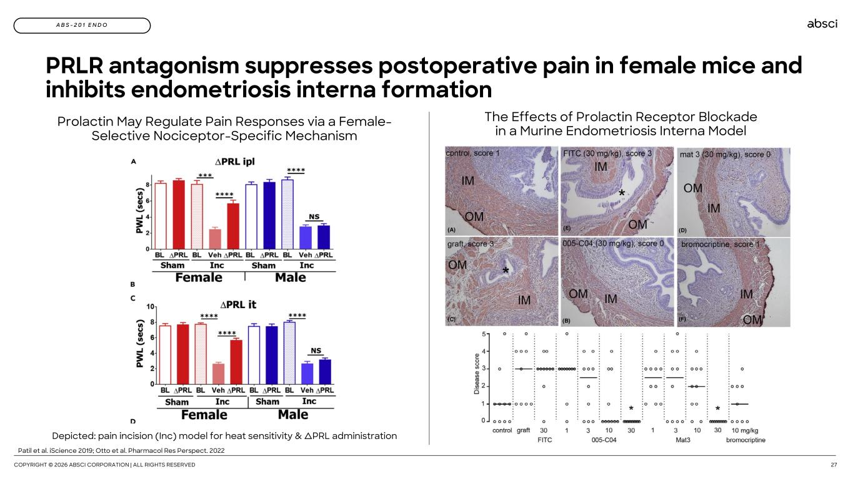
COPYRIGHT © 2026 ABSCI CORPORATION | ALL RIGHTS RESERVED 27 A B S - 2 0 1 E N D O Prolactin May Regulate Pain Responses via a Female- Selective Nociceptor-Specific Mechanism PRLR antagonism suppresses postoperative pain in female mice and inhibits endometriosis interna formation The Effects of Prolactin Receptor Blockade in a Murine Endometriosis Interna Model Patil et al. iScience 2019; Otto et al. Pharmacol Res Perspect. 2022 Depicted: pain incision (Inc) model for heat sensitivity & ∆PRL administration

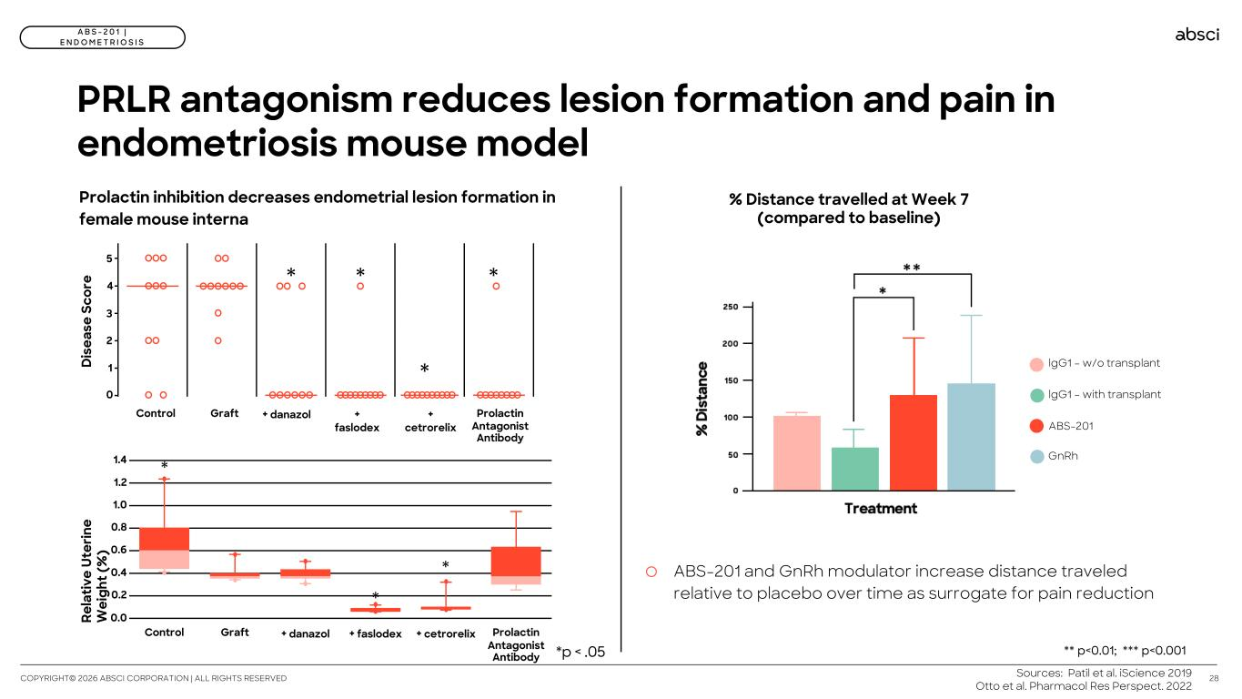
PRLR antagonism reduces lesion formation and pain in endometriosis mouse model 28 A B S - 2 0 1 | E N D O M E T R I O S I S COPYRIGHT© 2026 ABSCI CORPORATION | ALL RIGHTS RESERVED * 1 2 3 4 5 0 * * *D is ea se S co re Control Graft + danazol + faslodex + cetrorelix Prolactin Antagonist Antibody Prolactin inhibition decreases endometrial lesion formation in female mouse interna Re la tiv e Ut er in e W ei gh t ( % ) 0.0 0.2 0.4 0.6 0.8 1.0 1.2 1.4 * Control Graft + danazol + faslodex + cetrorelix Prolactin Antagonist Antibody * * Sources: Patil et al. iScience 2019 Otto et al. Pharmacol Res Perspect. 2022 % Distance travelled at Week 7 (compared to baseline) lgG1 – w/o transplant lgG1 – with transplant ABS-201 GnRh o ABS-201 and GnRh modulator increase distance traveled relative to placebo over time as surrogate for pain reduction *p < .05 ** p<0.01; *** p<0.001

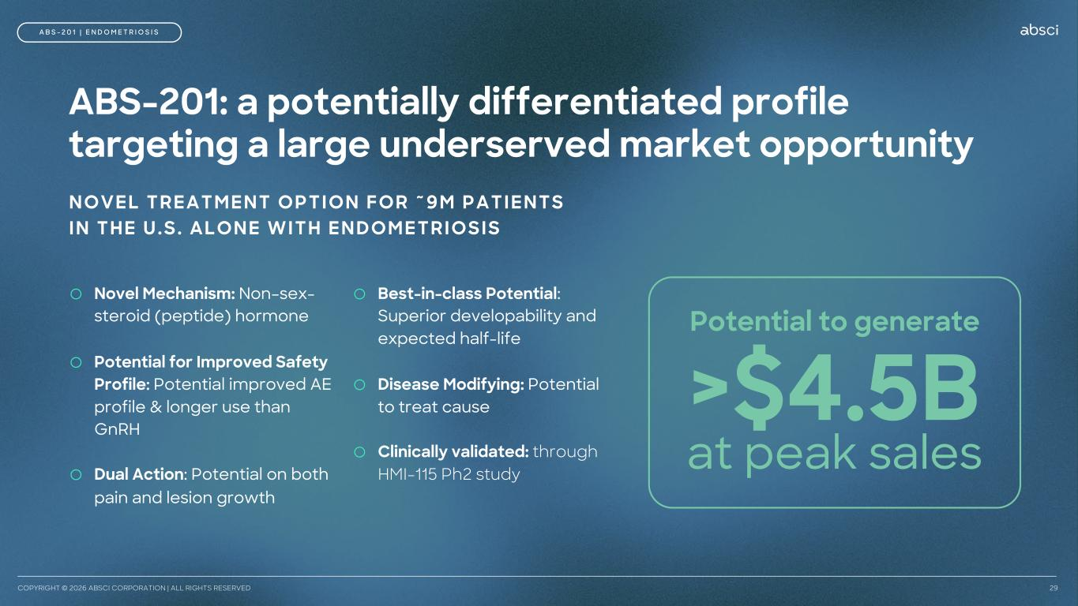
COPYRIGHT © 2026 ABSCI CORPORATION | ALL RIGHTS RESERVED 29 >$4.5B at peak sales Potential to generate A B S - 2 0 1 | E N D O M E T R I O S I S ABS-201: a potentially differentiated profile targeting a large underserved market opportunity NOVEL TREATMENT OPTION FOR ~9M PATIENTS IN THE U.S. ALONE WITH ENDOMETRIOSIS o Novel Mechanism: Non–sex- steroid (peptide) hormone o Potential for Improved Safety Profile: Potential improved AE profile & longer use than GnRH o Dual Action: Potential on both pain and lesion growth o Best-in-class Potential: Superior developability and expected half-life o Disease Modifying: Potential to treat cause o Clinically validated: through HMI-115 Ph2 study

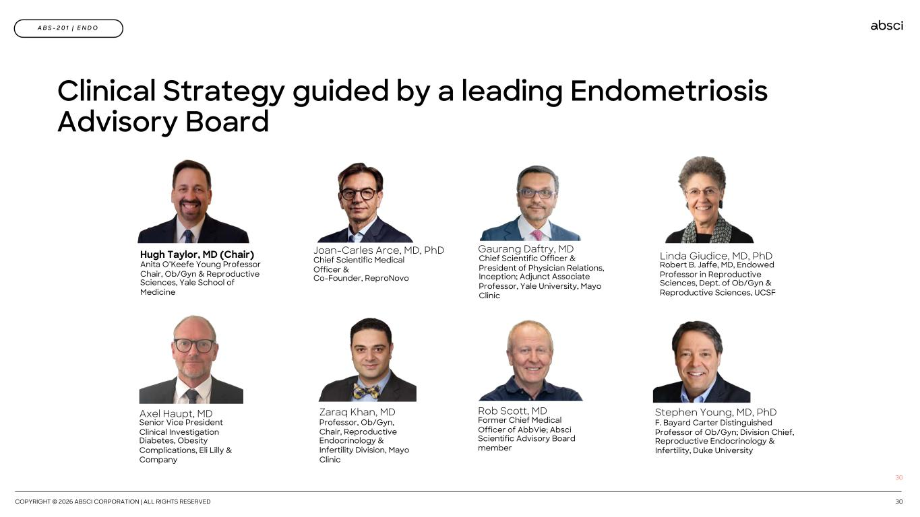
COPYRIGHT © 2026 ABSCI CORPORATION | ALL RIGHTS RESERVED 30 30 Hugh Taylor, MD (Chair) Anita O’Keefe Young Professor Chair, Ob/Gyn & Reproductive Sciences, Yale School of Medicine Zaraq Khan, MD Professor, Ob/Gyn, Chair, Reproductive Endocrinology & Infertility Division, Mayo Clinic Gaurang Daftry, MD Chief Scientific Officer & President of Physician Relations, Inception; Adjunct Associate Professor, Yale University, Mayo Clinic Stephen Young, MD, PhD F. Bayard Carter Distinguished Professor of Ob/Gyn; Division Chief, Reproductive Endocrinology & Infertility, Duke University Linda Giudice, MD, PhD Robert B. Jaffe, MD, Endowed Professor in Reproductive Sciences, Dept. of Ob/Gyn & Reproductive Sciences, UCSF Joan-Carles Arce, MD, PhD Chief Scientific Medical Officer & Co-Founder, ReproNovo Axel Haupt, MD Senior Vice President Clinical Investigation Diabetes, Obesity Complications, Eli Lilly & Company Rob Scott, MD Former Chief Medical Officer of AbbVie; Absci Scientific Advisory Board member A B S - 2 0 1 | E N D O Clinical Strategy guided by a leading Endometriosis Advisory Board

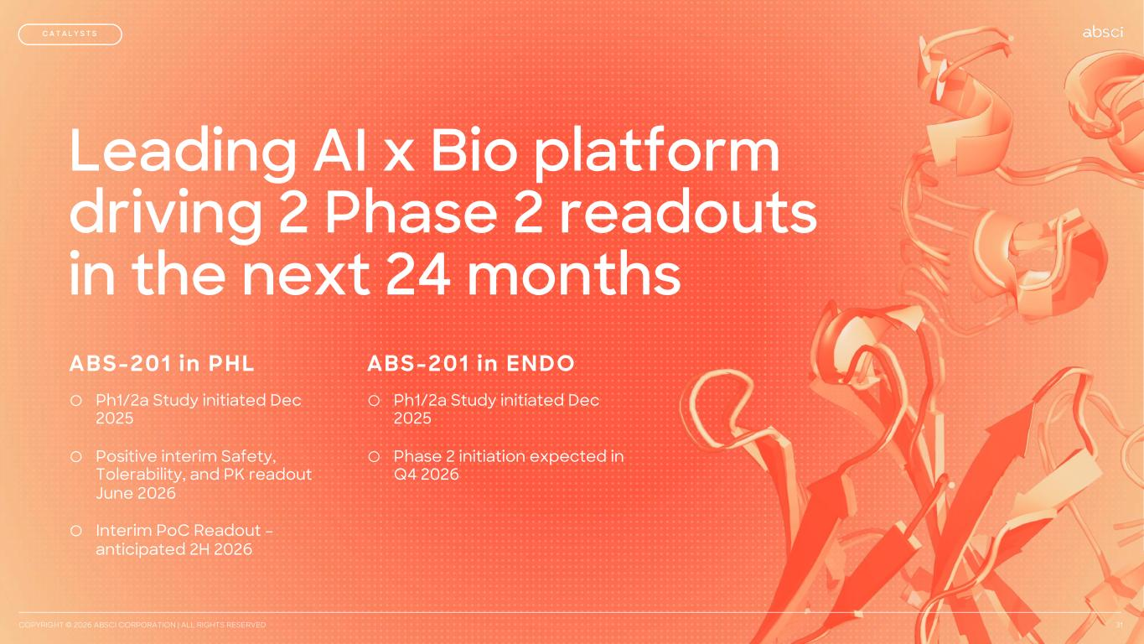
Leading AI x Bio platform driving 2 Phase 2 readouts in the next 24 months COPYRIGHT © 2026 ABSCI CORPORATION | ALL RIGHTS RESERVED 31 C A T A L Y S T S ABS-201 in PHL o Ph1/2a Study initiated Dec 2025 o Positive interim Safety, Tolerability, and PK readout June 2026 o Interim PoC Readout – anticipated 2H 2026 ABS-201 in ENDO o Ph1/2a Study initiated Dec 2025 o Phase 2 initiation expected in Q4 2026

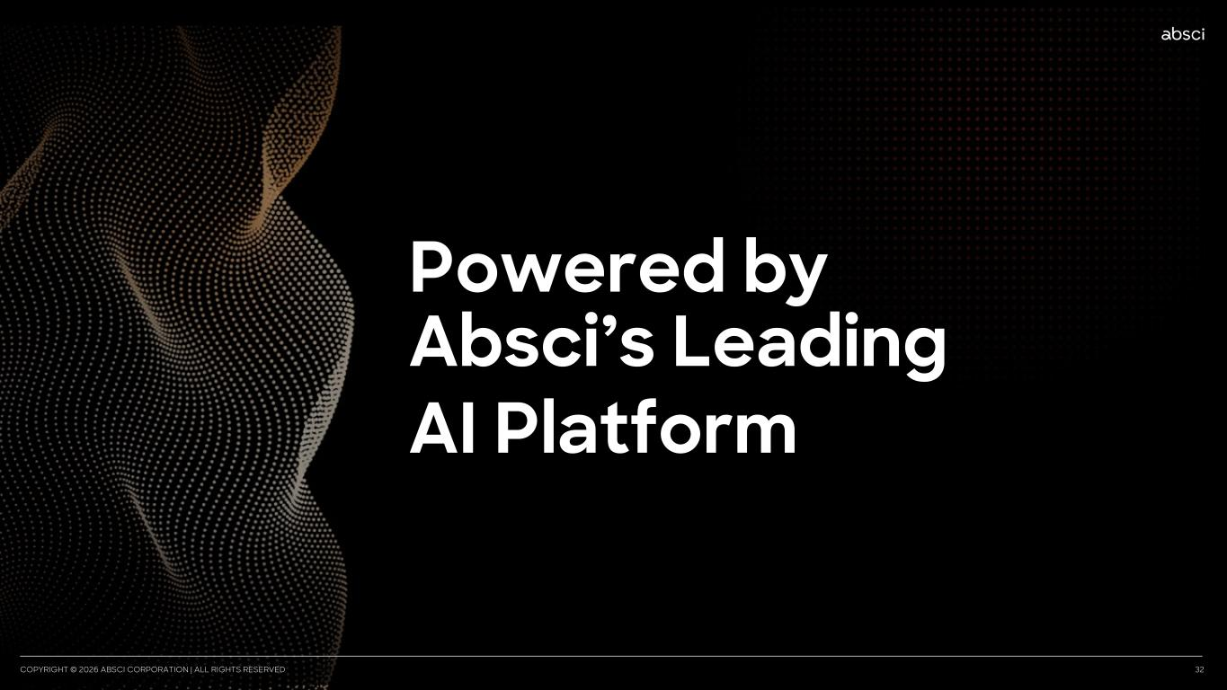
CONFIDENTIAL AND PROPRIETARY | COPYRIGHT © 2026 ABSCI CORPORATION | ALL RIGHTS RESERVED 32PYRIGH © 2026 ABSCI CORPORATION | ALL RIGHTS RE ERVED Powered by Absci’s Leading AI Platform

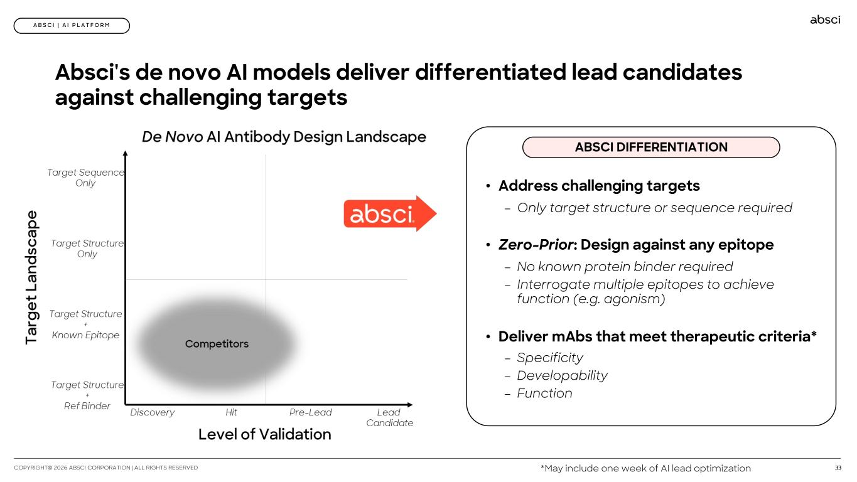
33COPYRIGHT© 2026 ABSCI CORPORATION | ALL RIGHTS RESERVED A B S C I | A I P L A T F O R M Absci's de novo AI models deliver differentiated lead candidates against challenging targets *May include one week of AI lead optimization • Address challenging targets – Only target structure or sequence required • Zero-Prior: Design against any epitope – No known protein binder required – Interrogate multiple epitopes to achieve function (e.g. agonism) • Deliver mAbs that meet therapeutic criteria* – Specificity – Developability – Function ABSCI DIFFERENTIATION

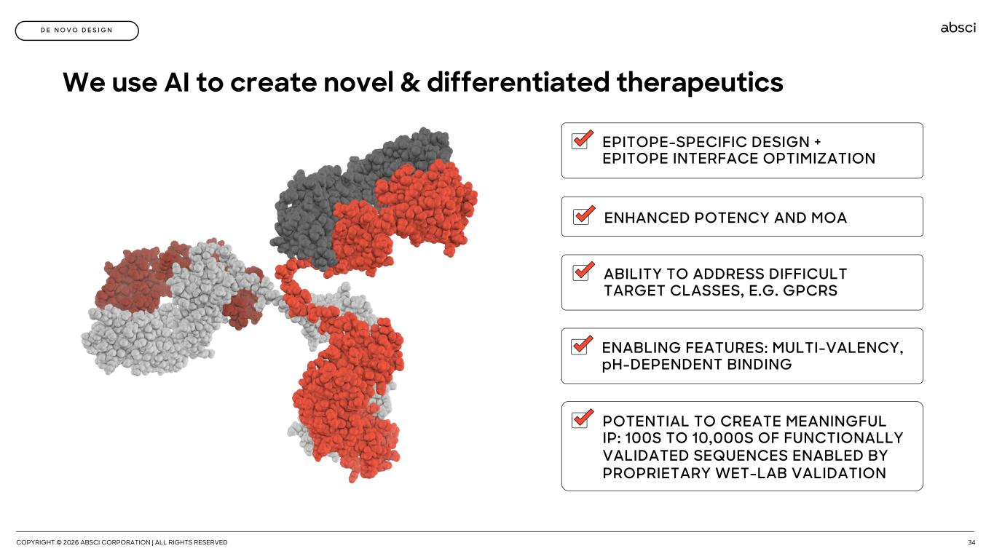
COPYRIGHT © 2026 ABSCI CORPORATION | ALL RIGHTS RESERVED 34 D E N O V O D E S I G N We use AI to create novel & differentiated therapeutics ENABLING FEATURES: MULTI-VALENCY, pH-DEPENDENT BINDING ABILITY TO ADDRESS DIFFICULT TARGET CLASSES, E.G. GPCRS EPITOPE-SPECIFIC DESIGN + EPITOPE INTERFACE OPTIMIZATION POTENTIAL TO CREATE MEANINGFUL IP: 100S TO 10,000S OF FUNCTIONALLY VALIDATED SEQUENCES ENABLED BY PROPRIETARY WET-LAB VALIDATION ENHANCED POTENCY AND MOA

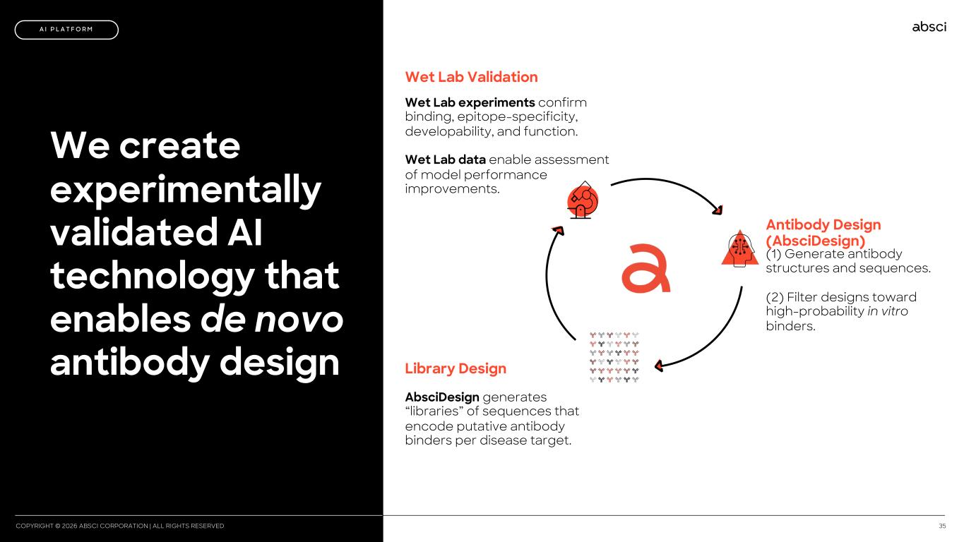
COPYRIGHT © 2026 ABSCI CORPORATION | ALL RIGHTS RESERVED 35 We create experimentally validated AI technology that enables de novo antibody design A I P L A T F O R M Antibody Design (AbsciDesign) Library Design Wet Lab Validation (1) Generate antibody structures and sequences. (2) Filter designs toward high-probability in vitro binders. AbsciDesign generates “libraries” of sequences that encode putative antibody binders per disease target. Wet Lab experiments confirm binding, epitope-specificity, developability, and function. Wet Lab data enable assessment of model performance improvements.

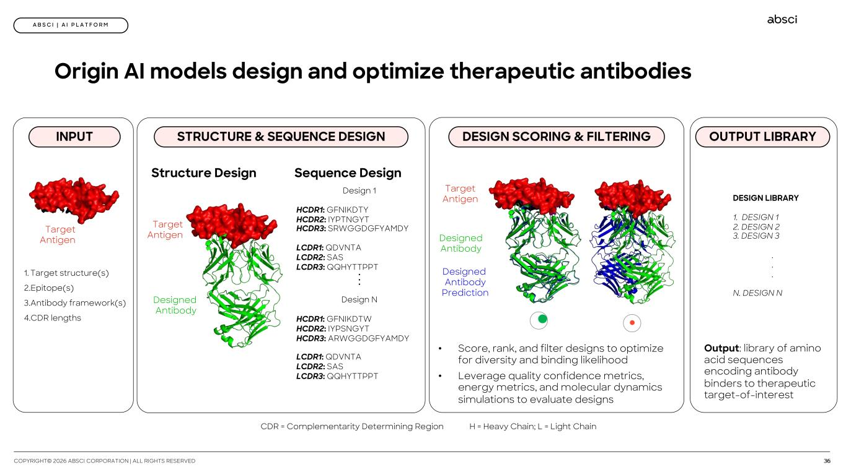
36COPYRIGHT© 2026 ABSCI CORPORATION | ALL RIGHTS RESERVED A B S C I | A I P L A T F O R M 1. Target structure(s) 2.Epitope(s) 3.Antibody framework(s) 4.CDR lengths CDR = Complementarity Determining Region H = Heavy Chain; L = Light Chain Design 1 HCDR1: GFNIKDTY HCDR2: IYPTNGYT HCDR3: SRWGGDGFYAMDY LCDR1: QDVNTA LCDR2: SAS LCDR3: QQHYTTPPT... Design N HCDR1: GFNIKDTW HCDR2: IYPSNGYT HCDR3: ARWGGDGFYAMDY LCDR1: QDVNTA LCDR2: SAS LCDR3: QQHYTTPPT Designed Antibody Target Antigen Structure Design Sequence Design • Score, rank, and filter designs to optimize for diversity and binding likelihood • Leverage quality confidence metrics, energy metrics, and molecular dynamics simulations to evaluate designs Designed Antibody Designed Antibody Prediction Target Antigen Target Antigen Origin AI models design and optimize therapeutic antibodies INPUT STRUCTURE & SEQUENCE DESIGN DESIGN SCORING & FILTERING OUTPUT LIBRARY DESIGN LIBRARY 1. DESIGN 1 2. DESIGN 2 3. DESIGN 3 . . . N. DESIGN N Output: library of amino acid sequences encoding antibody binders to therapeutic target-of-interest 

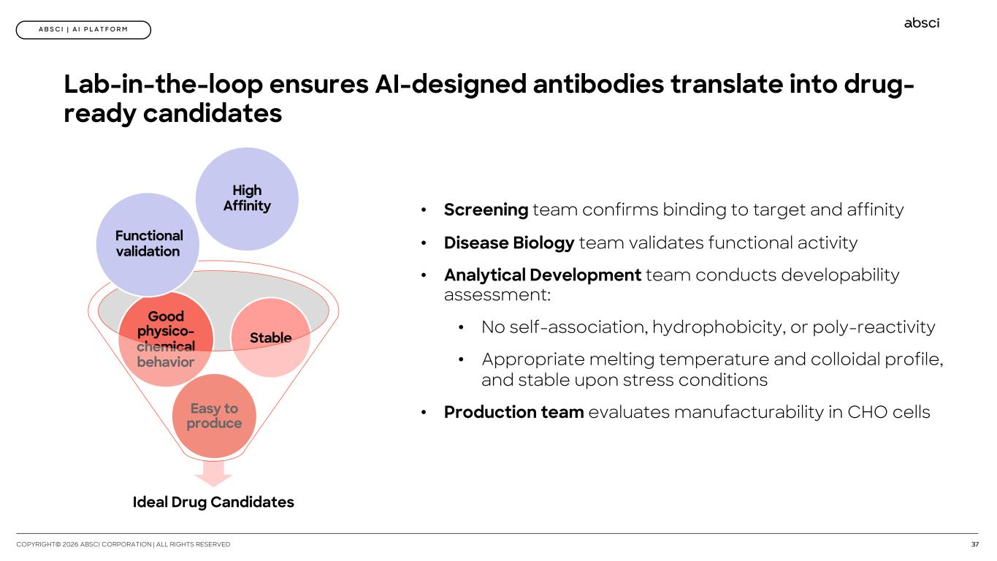
37COPYRIGHT© 2026 ABSCI CORPORATION | ALL RIGHTS RESERVED A B S C I | A I P L A T F O R M Lab-in-the-loop ensures AI-designed antibodies translate into drug- ready candidates Ideal Drug Candidates Easy to produce Good physico- chemical behavior Stable High Affinity Functional validation • Screening team confirms binding to target and affinity • Disease Biology team validates functional activity • Analytical Development team conducts developability assessment: • No self-association, hydrophobicity, or poly-reactivity • Appropriate melting temperature and colloidal profile, and stable upon stress conditions • Production team evaluates manufacturability in CHO cells

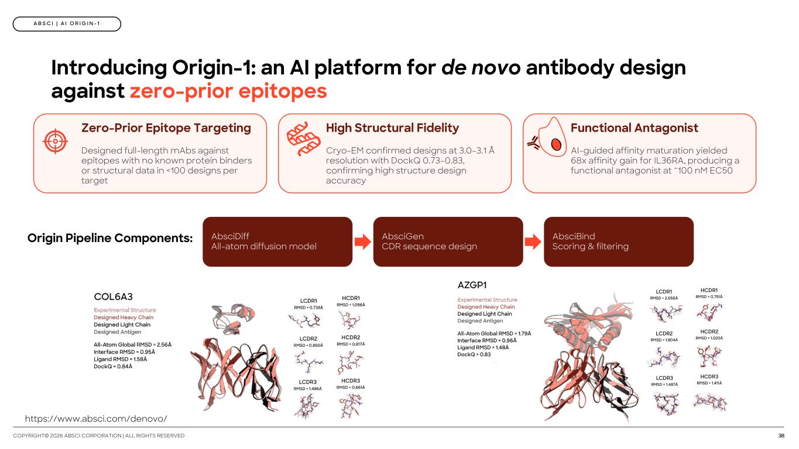
38COPYRIGHT© 2026 ABSCI CORPORATION | ALL RIGHTS RESERVED Introducing Origin-1: an AI platform for de novo antibody design against zero-prior epitopes Zero-Prior Epitope Targeting Designed full-length mAbs against epitopes with no known protein binders or structural data in <100 designs per target High Structural Fidelity Cryo-EM confirmed designs at 3.0–3.1 Å resolution with DockQ 0.73–0.83, confirming high structure design accuracy Functional Antagonist AI-guided affinity maturation yielded 68x affinity gain for IL36RA, producing a functional antagonist at ~100 nM EC50 Origin Pipeline Components: AbsciDiff All-atom diffusion model AbsciGen CDR sequence design AbsciBind Scoring & filtering A B S C I | A I O R I G I N - 1 https://www.absci.com/denovo/

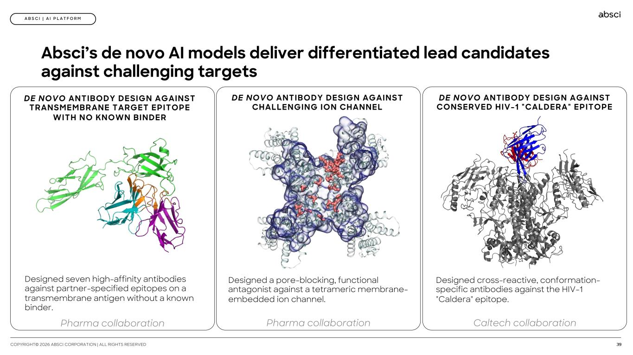
39COPYRIGHT© 2026 ABSCI CORPORATION | ALL RIGHTS RESERVED A B S C I | A I P L A T F O R M Absci’s de novo AI models deliver differentiated lead candidates against challenging targets DE NOVO ANTIBODY DESIGN AGAINST TRANSMEMBRANE TARGET EPITOPE WITH NO KNOWN BINDER Designed seven high-affinity antibodies against partner-specified epitopes on a transmembrane antigen without a known binder. Pharma collaboration DE NOVO ANTIBODY DESIGN AGAINST CHALLENGING ION CHANNEL Designed a pore-blocking, functional antagonist against a tetrameric membrane- embedded ion channel. Pharma collaboration DE NOVO ANTIBODY DESIGN AGAINST CONSERVED HIV-1 "CALDERA" EPITOPE Designed cross-reactive, conformation- specific antibodies against the HIV-1 "Caldera" epitope. Caltech collaboration

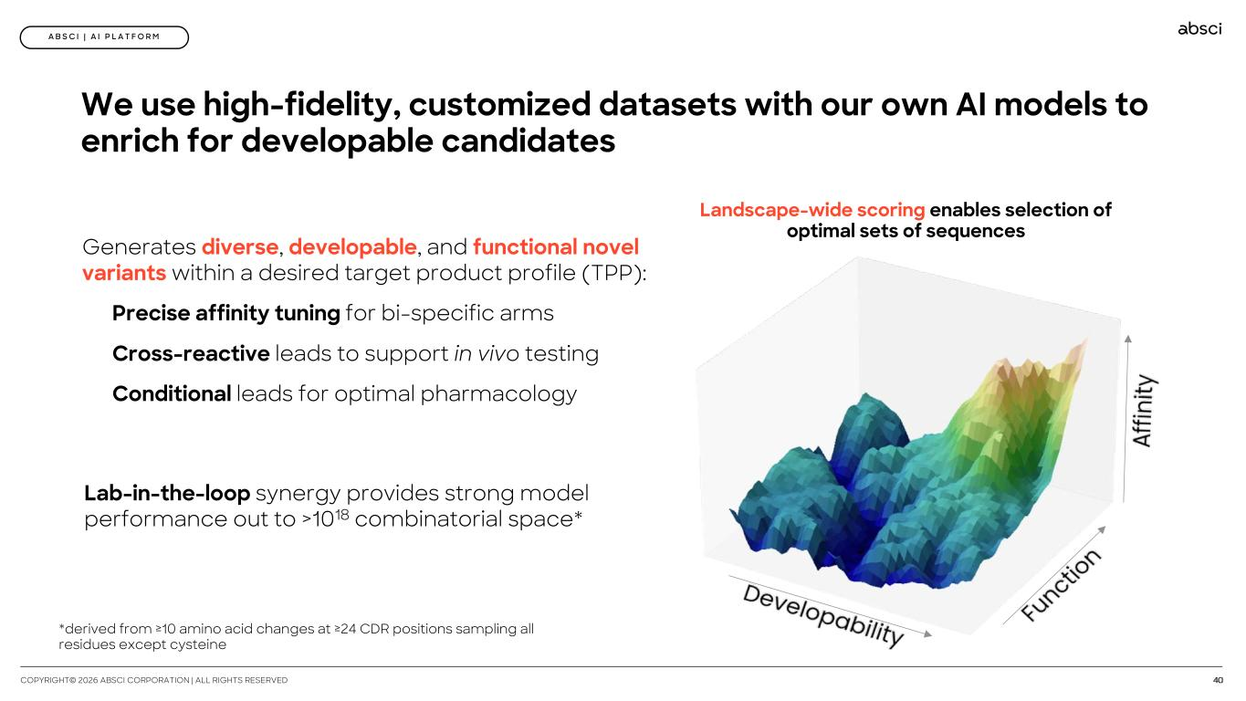
40COPYRIGHT© 2026 ABSCI CORPORATION | ALL RIGHTS RESERVED A B S C I | A I P L A T F O R M We use high-fidelity, customized datasets with our own AI models to enrich for developable candidates Lab-in-the-loop synergy provides strong model performance out to >1018 combinatorial space* Generates diverse, developable, and functional novel variants within a desired target product profile (TPP): Precise affinity tuning for bi-specific arms Cross-reactive leads to support in vivo testing Conditional leads for optimal pharmacology Landscape-wide scoring enables selection of optimal sets of sequences *derived from ≥10 amino acid changes at ≥24 CDR positions sampling all residues except cysteine

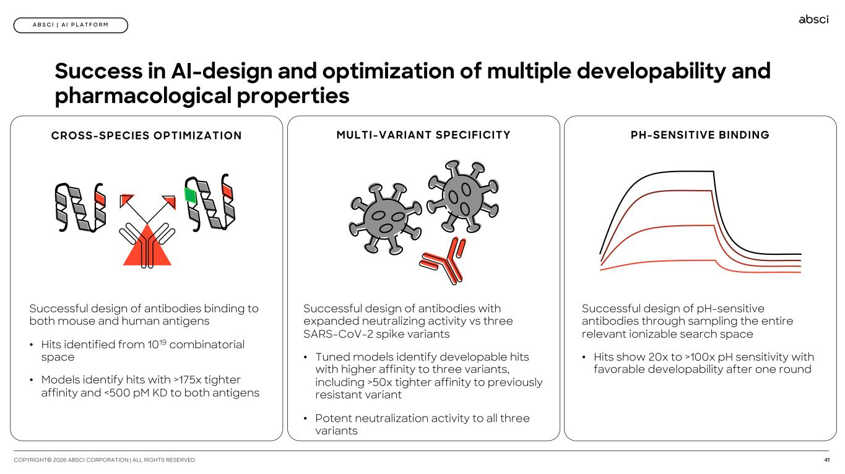
41COPYRIGHT© 2026 ABSCI CORPORATION | ALL RIGHTS RESERVED A B S C I | A I P L A T F O R M Success in AI-design and optimization of multiple developability and pharmacological properties CROSS-SPECIES OPTIMIZATION Successful design of antibodies binding to both mouse and human antigens • Hits identified from 1019 combinatorial space • Models identify hits with >175x tighter affinity and <500 pM KD to both antigens MULTI-VARIANT SPECIFICITY Successful design of antibodies with expanded neutralizing activity vs three SARS-CoV-2 spike variants • Tuned models identify developable hits with higher affinity to three variants, including >50x tighter affinity to previously resistant variant • Potent neutralization activity to all three variants PH-SENSITIVE BINDING Successful design of pH-sensitive antibodies through sampling the entire relevant ionizable search space • Hits show 20x to >100x pH sensitivity with favorable developability after one round

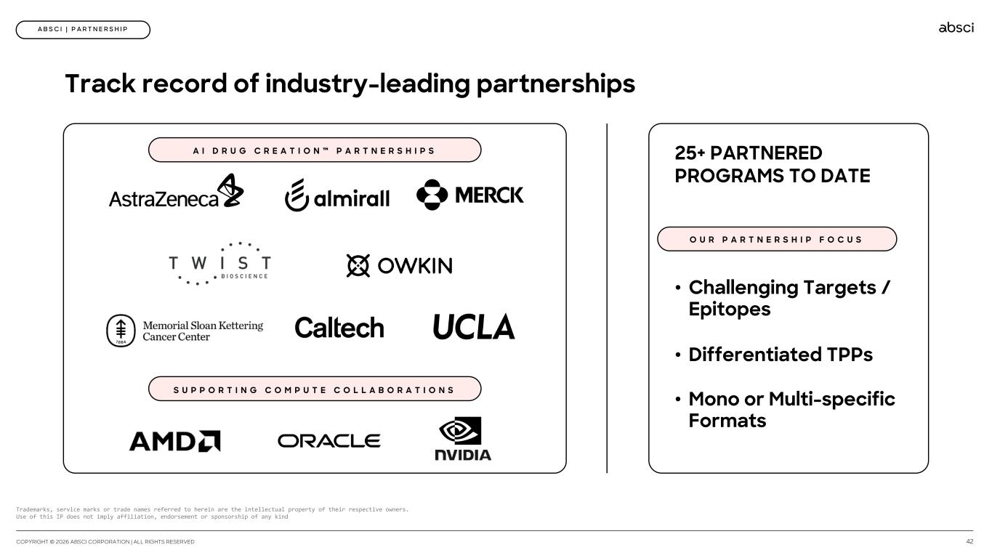
Track record of industry-leading partnerships A I D R U G C R E A T I O N ™ P A R T N E R S H I P S O U R P A R T N E R S H I P F O C U S 25+ PARTNERED PROGRAMS TO DATE • Challenging Targets / Epitopes • Differentiated TPPs • Mono or Multi-specific Formats A B S C I | P A R T N E R S H I P S U P P O R T I N G C O M P U T E C O L L A B O R A T I O N S Trademarks, service marks or trade names referred to herein are the intellectual property of their respective owners. Use of this IP does not imply affiliation, endorsement or sponsorship of any kind 42COPYRIGHT © 2026 ABSCI CORPORATION | ALL RIGHTS RESERVED

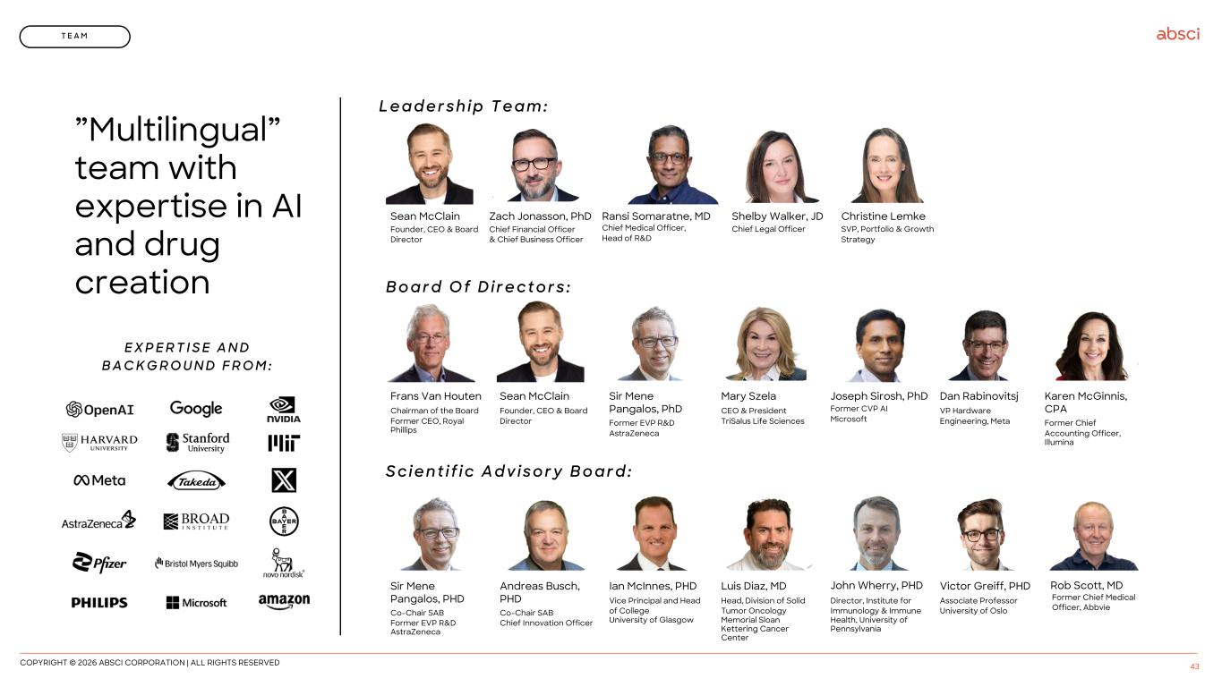
”Multilingual” team with expertise in AI and drug creation COPYRIGHT © 2026 ABSCI CORPORATION | ALL RIGHTS RESERVED 43 T E A M Sean McClain Founder, CEO & Board Director Zach Jonasson, PhD Chief Financial Officer & Chief Business Officer Shelby Walker, JD Chief Legal Officer Christine Lemke SVP, Portfolio & Growth Strategy L e a d e r s h i p T e a m : Sean McClain Founder, CEO & Board Director Sir Mene Pangalos, PhD Former EVP R&D AstraZeneca Mary Szela CEO & President TriSalus Life Sciences Joseph Sirosh, PhD Former CVP AI Microsoft Dan Rabinovitsj VP Hardware Engineering, Meta Karen McGinnis, CPA Former Chief Accounting Officer, Illumina Frans Van Houten Chairman of the Board Former CEO, Royal Phillips B o a r d O f D i r e c t o r s : Andreas Busch, PHD Co-Chair SAB Chief Innovation Officer Ian McInnes, PHD Vice Principal and Head of College University of Glasgow Luis Diaz, MD Head, Division of Solid Tumor Oncology Memorial Sloan Kettering Cancer Center John Wherry, PHD Director, Institute for Immunology & Immune Health, University of Pennsylvania Victor Greiff, PHD Associate Professor University of Oslo Sir Mene Pangalos, PHD Co-Chair SAB Former EVP R&D AstraZeneca S c i e n t i f i c A d v i s o r y B o a r d : Ransi Somaratne, MD Chief Medical Officer, Head of R&D E X P E R T I S E A N D B A C K G R O U N D F R O M : Rob Scott, MD Former Chief Medical Officer, Abbvie

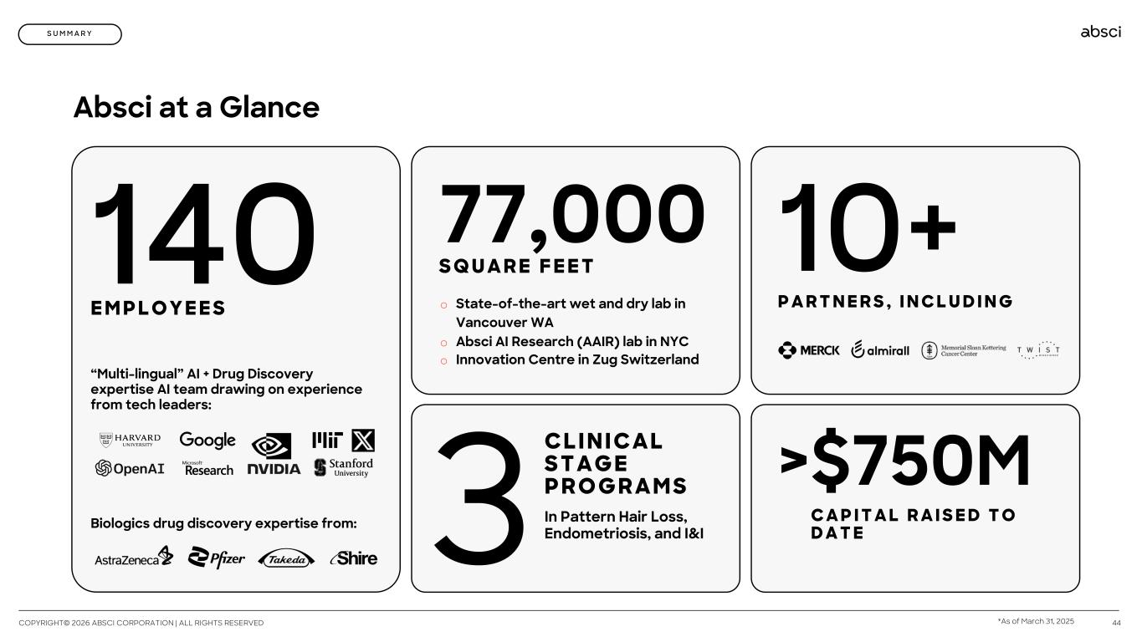
44 140 E M P L O Y E E S Biologics drug discovery expertise from: “Multi-lingual” AI + Drug Discovery expertise AI team drawing on experience from tech leaders: 77,000 S Q U A R E F E E T o State-of-the-art wet and dry lab in Vancouver WA o Absci AI Research (AAIR) lab in NYC o Innovation Centre in Zug Switzerland 3 CLI NI CAL STAGE PR O GR AMS In Pattern Hair Loss, Endometriosis, and I&I >$750M C A P I T A L R A I S E D T O D A T E 10+ P A R T N E R S , I N C L U D I N G Absci at a Glance S U M M A R Y COPYRIGHT© 2026 ABSCI CORPORATION | ALL RIGHTS RESERVED *As of March 31, 2025


Generative AI Re(Generative) Biology A B S C I C O R P O R A T I O N 2 0 2 6 A L L R I G H T S R E S E R V E D

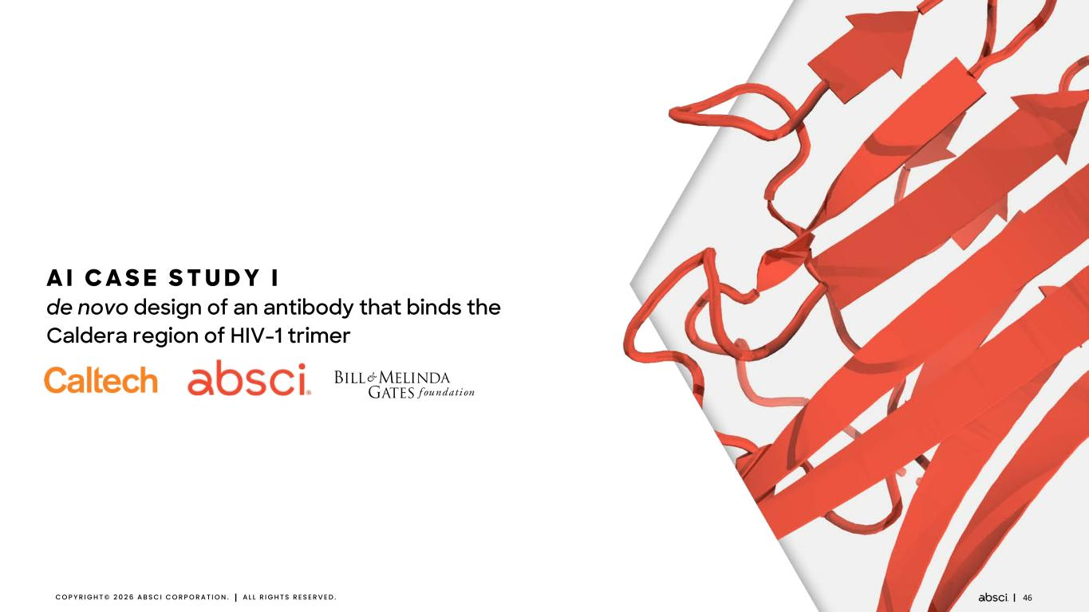
46C O P Y R I G H T © 2 0 2 6 A B S C I C O R P O R A T I O N . A L L R I G H T S R E S E R V E D . A I C A S E S T U D Y I de novo design of an antibody that binds the Caldera region of HIV-1 trimer

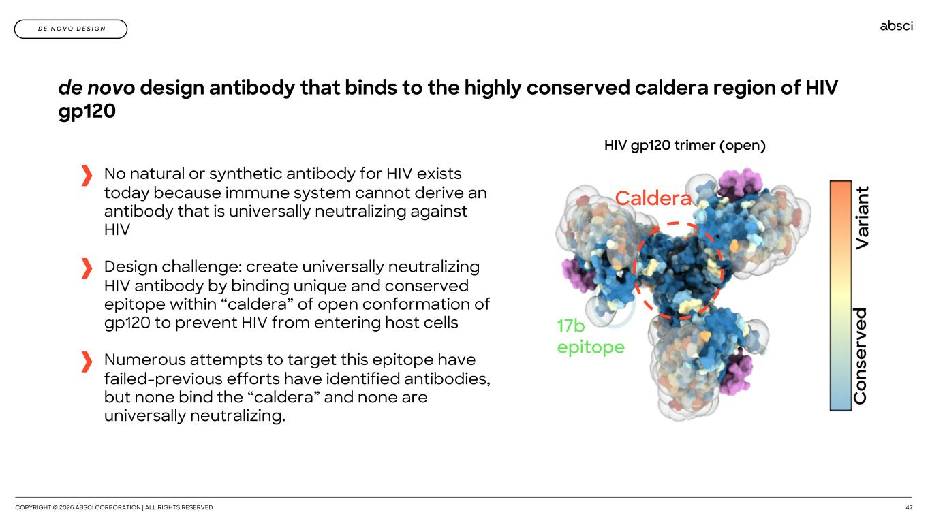
COPYRIGHT © 2026 ABSCI CORPORATION | ALL RIGHTS RESERVED 47 No natural or synthetic antibody for HIV exists today because immune system cannot derive an antibody that is universally neutralizing against HIV Design challenge: create universally neutralizing HIV antibody by binding unique and conserved epitope within “caldera” of open conformation of gp120 to prevent HIV from entering host cells Numerous attempts to target this epitope have failed-previous efforts have identified antibodies, but none bind the “caldera” and none are universally neutralizing. D E N O V O D E S I G N de novo design antibody that binds to the highly conserved caldera region of HIV gp120 17b epitope Caldera HIV gp120 trimer (open)

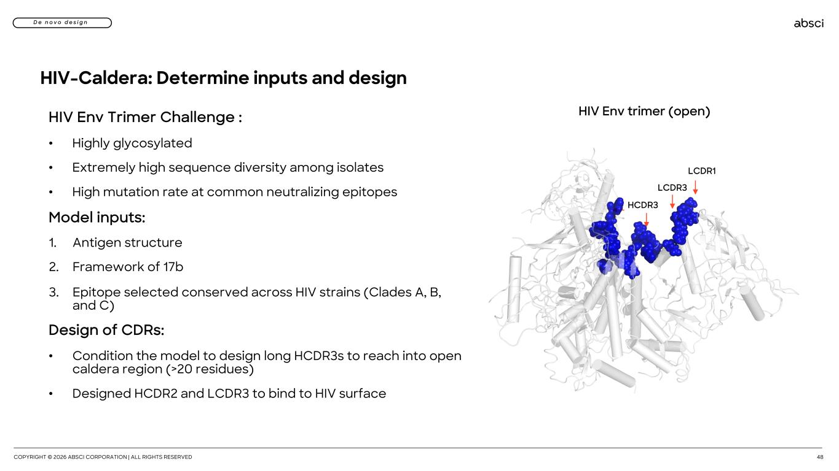
COPYRIGHT © 2026 ABSCI CORPORATION | ALL RIGHTS RESERVED 48 D e n o v o d e s i g n HIV-Caldera: Determine inputs and design HIV Env Trimer Challenge : • Highly glycosylated • Extremely high sequence diversity among isolates • High mutation rate at common neutralizing epitopes Model inputs: 1. Antigen structure 2. Framework of 17b 3. Epitope selected conserved across HIV strains (Clades A, B, and C) Design of CDRs: • Condition the model to design long HCDR3s to reach into open caldera region (>20 residues) • Designed HCDR2 and LCDR3 to bind to HIV surface HIV Env trimer (open) HCDR3 LCDR1 LCDR3

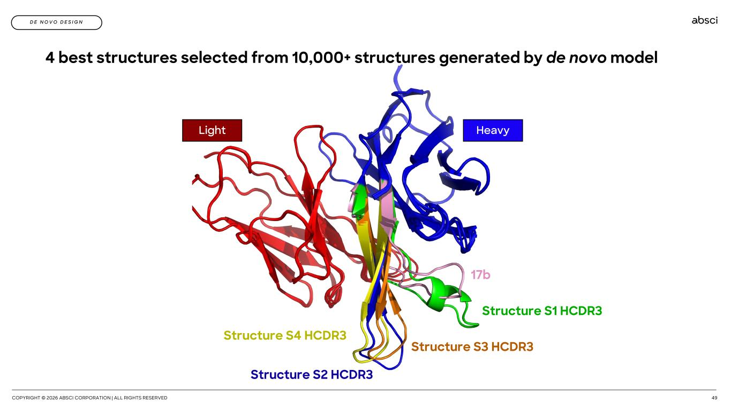
COPYRIGHT © 2026 ABSCI CORPORATION | ALL RIGHTS RESERVED 49 D E N O V O D E S I G N 4 best structures selected from 10,000+ structures generated by de novo model 17b Structure S1 HCDR3 Structure S3 HCDR3 Structure S2 HCDR3 Structure S4 HCDR3 HeavyLight

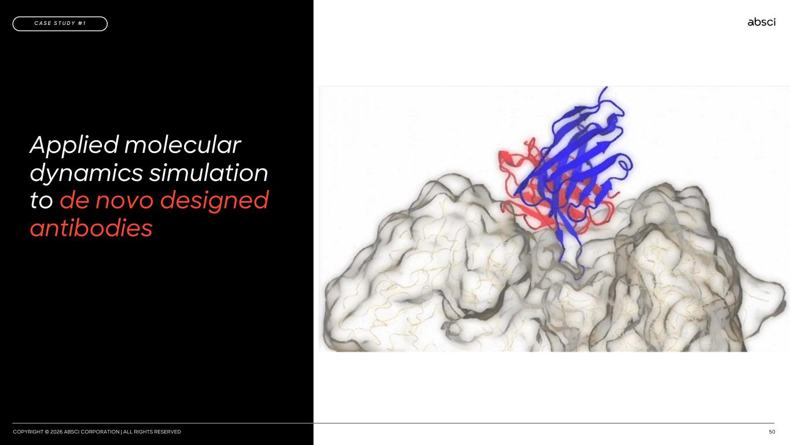
COPYRIGHT © 2026 ABSCI CORPORATION | ALL RIGHTS RESERVED 50 2024 20252024 2025 2026 Applied molecular dynamics simulation to de novo designed antibodies C A S E S T U D Y # 1

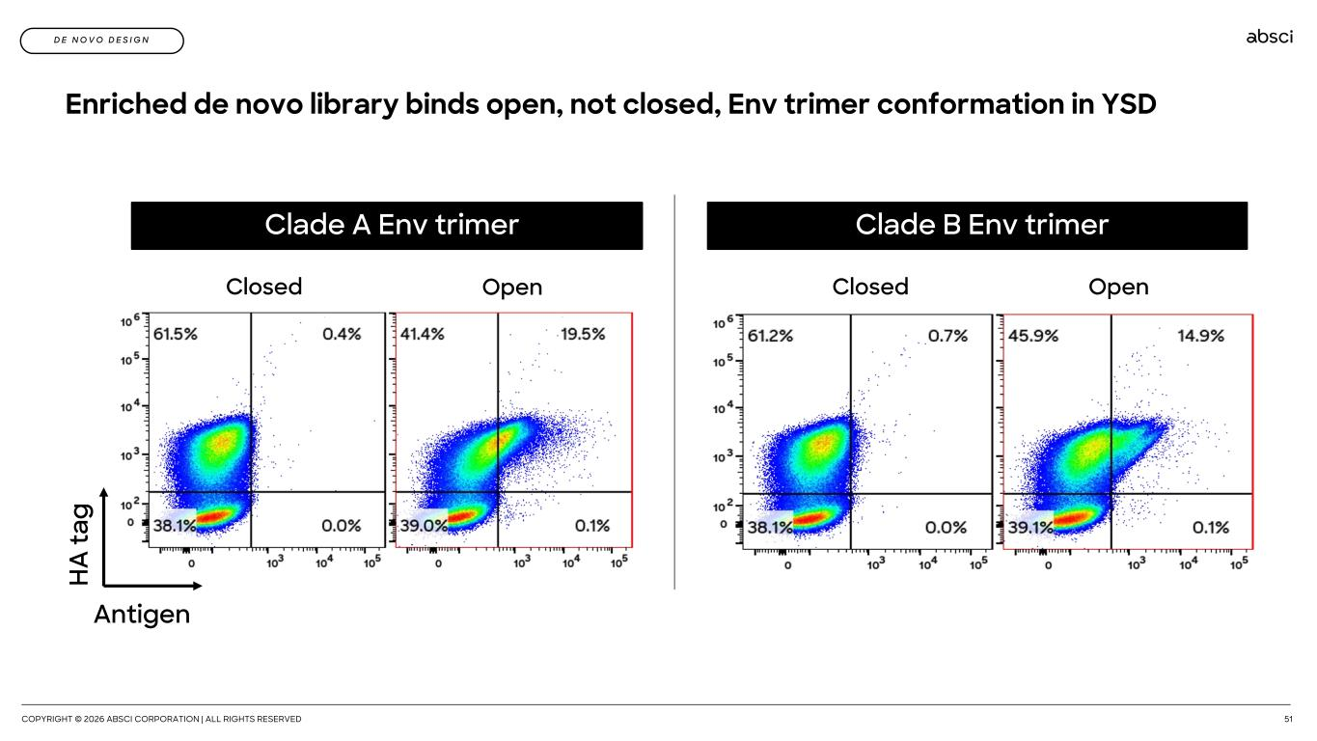
COPYRIGHT © 2026 ABSCI CORPORATION | ALL RIGHTS RESERVED 51 H A ta g Antigen Clade A Env trimer Closed Open Enriched de novo library binds open, not closed, Env trimer conformation in YSD Closed Open Clade B Env trimer D E N O V O D E S I G N

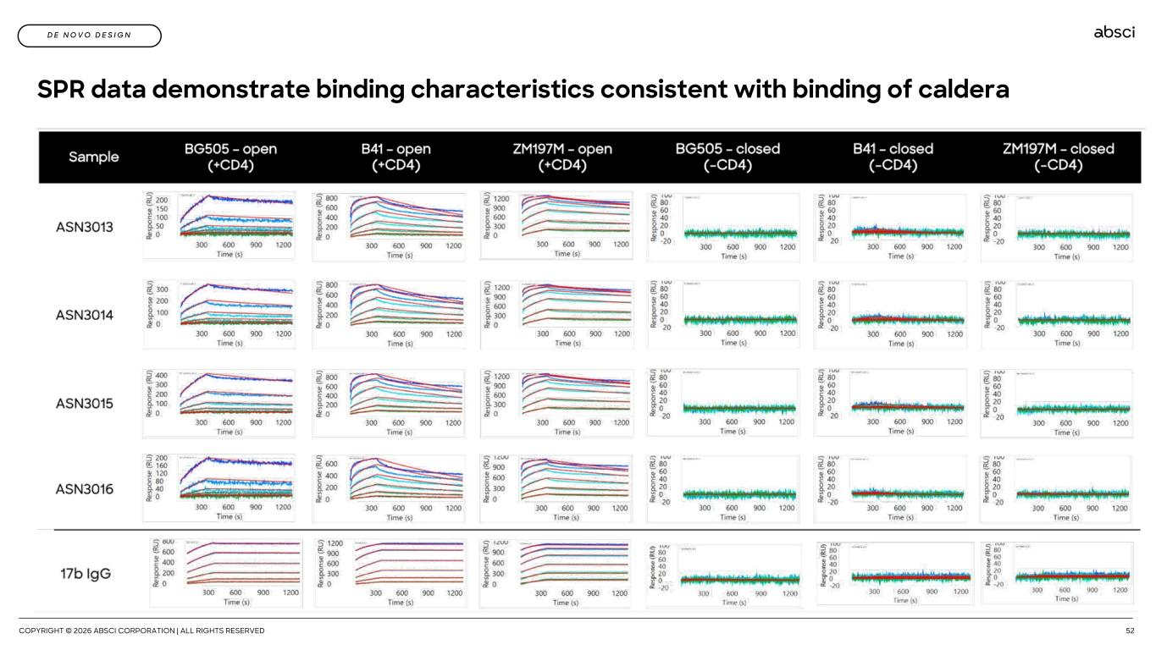
COPYRIGHT © 2026 ABSCI CORPORATION | ALL RIGHTS RESERVED 52 D E N O V O D E S I G N SPR data demonstrate binding characteristics consistent with binding of caldera

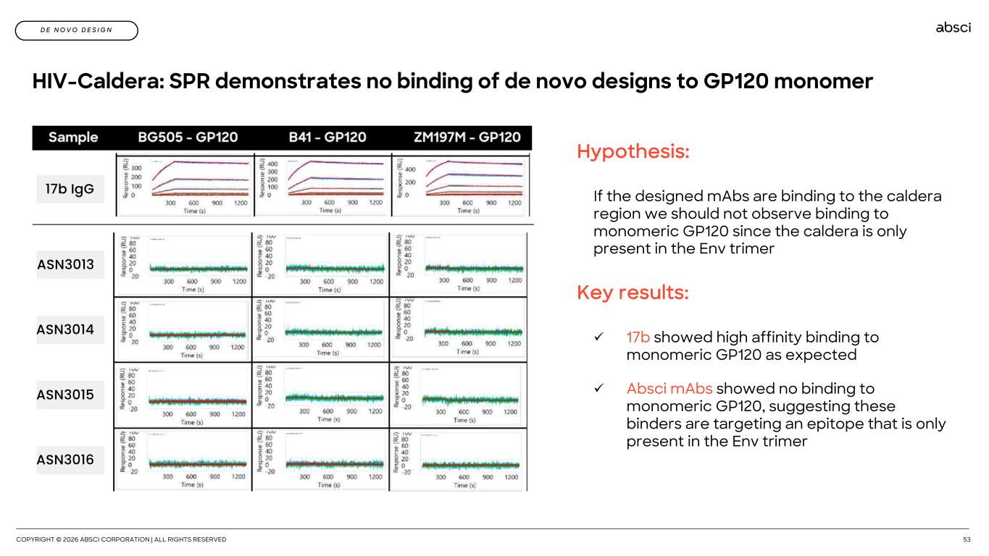
COPYRIGHT © 2026 ABSCI CORPORATION | ALL RIGHTS RESERVED 53 HIV-Caldera: SPR demonstrates no binding of de novo designs to GP120 monomer Hypothesis: If the designed mAbs are binding to the caldera region we should not observe binding to monomeric GP120 since the caldera is only present in the Env trimer Key results: ü 17b showed high affinity binding to monomeric GP120 as expected ü Absci mAbs showed no binding to monomeric GP120, suggesting these binders are targeting an epitope that is only present in the Env trimer ASN3013 ASN3014 ASN3015 ASN3016 17b IgG D E N O V O D E S I G N

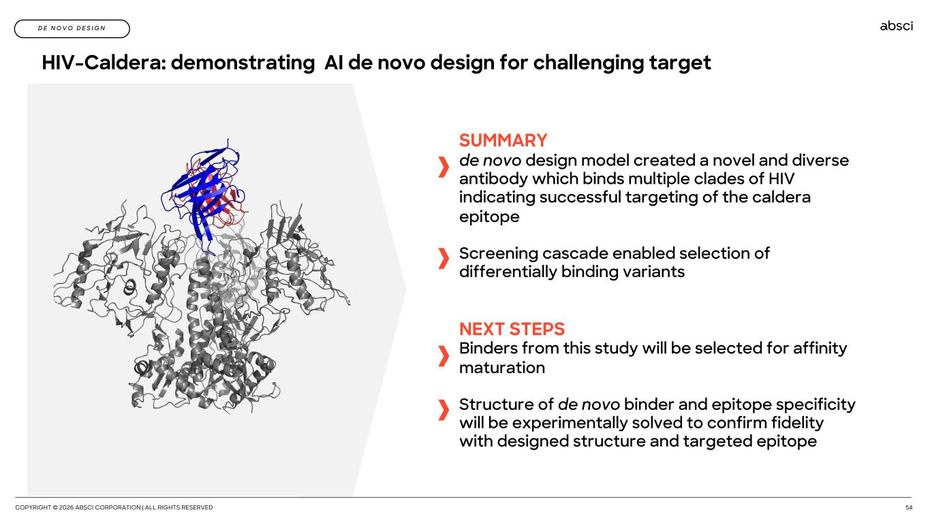
COPYRIGHT © 2026 ABSCI CORPORATION | ALL RIGHTS RESERVED 54 HIV-Caldera: demonstrating AI de novo design for challenging target SUMMARY de novo design model created a novel and diverse antibody which binds multiple clades of HIV indicating successful targeting of the caldera epitope Screening cascade enabled selection of differentially binding variants NEXT STEPS Binders from this study will be selected for affinity maturation Structure of de novo binder and epitope specificity will be experimentally solved to confirm fidelity with designed structure and targeted epitope D E N O V O D E S I G N

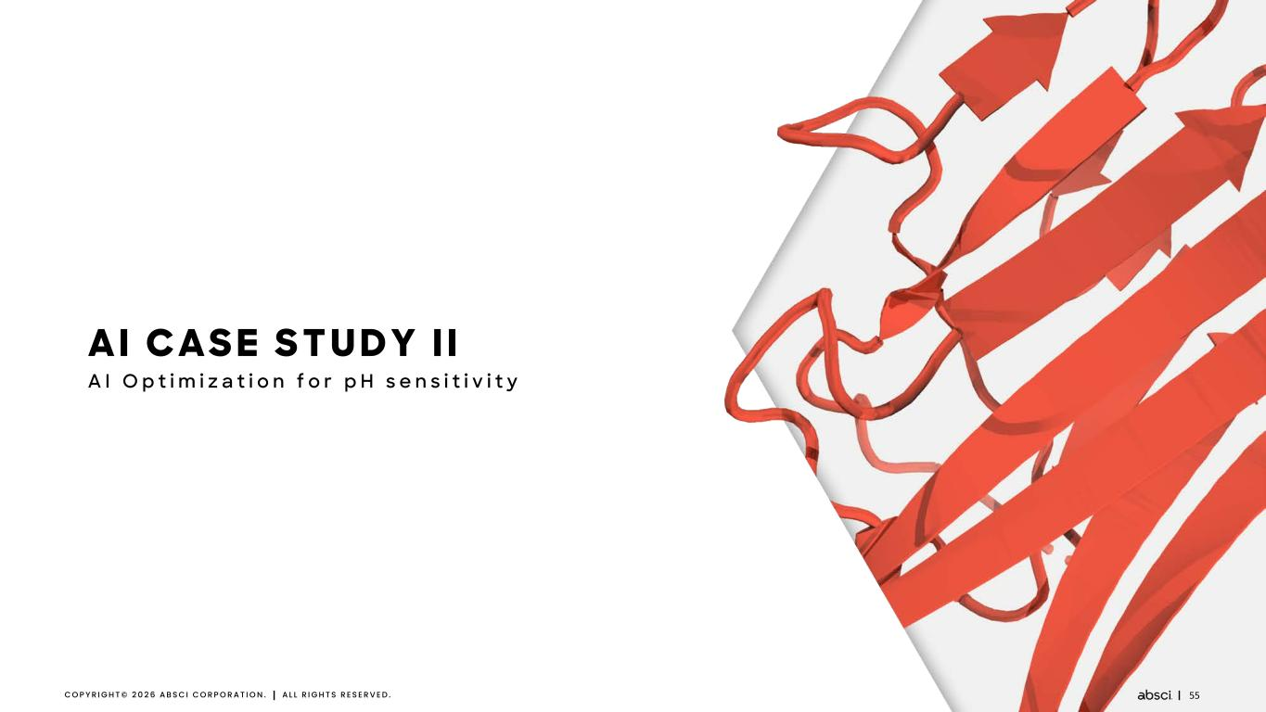
55C O P Y R I G H T © 2 0 2 6 A B S C I C O R P O R A T I O N . A L L R I G H T S R E S E R V E D . AI CASE STUDY I I A I O p t i m i z a t i o n f o r p H s e n s i t i v i t y

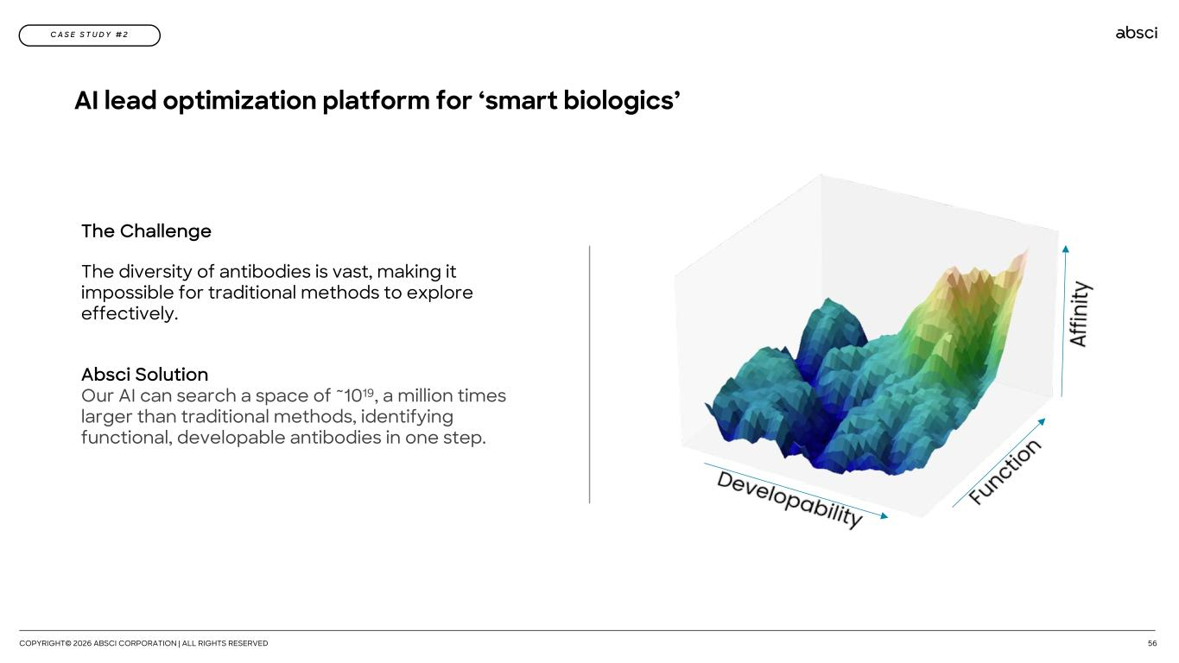
AI lead optimization platform for ‘smart biologics’ COPYRIGHT© 2026 ABSCI CORPORATION | ALL RIGHTS RESERVED 56 C A S E S T U D Y # 2 The Challenge The diversity of antibodies is vast, making it impossible for traditional methods to explore effectively. Absci Solution Our AI can search a space of ~1019, a million times larger than traditional methods, identifying functional, developable antibodies in one step.

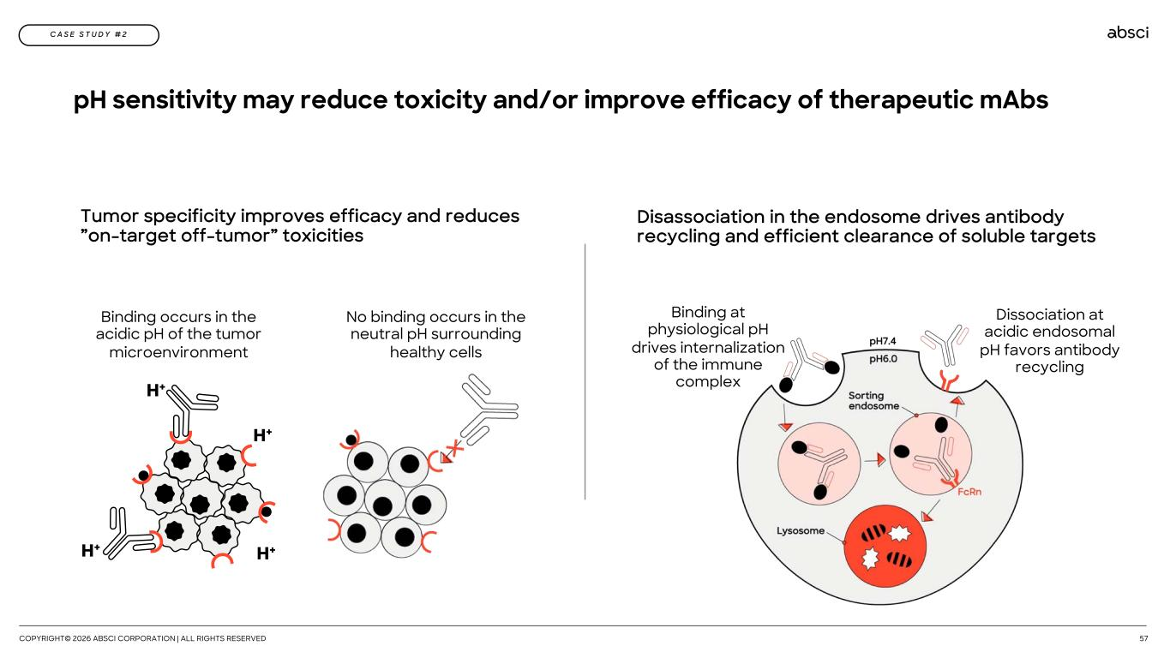
pH sensitivity may reduce toxicity and/or improve efficacy of therapeutic mAbs COPYRIGHT© 2026 ABSCI CORPORATION | ALL RIGHTS RESERVED 57 C A S E S T U D Y # 2 Tumor specificity improves efficacy and reduces ”on-target off-tumor” toxicities Binding occurs in the acidic pH of the tumor microenvironment No binding occurs in the neutral pH surrounding healthy cells Disassociation in the endosome drives antibody recycling and efficient clearance of soluble targets Dissociation at acidic endosomal pH favors antibody recycling Binding at physiological pH drives internalization of the immune complex

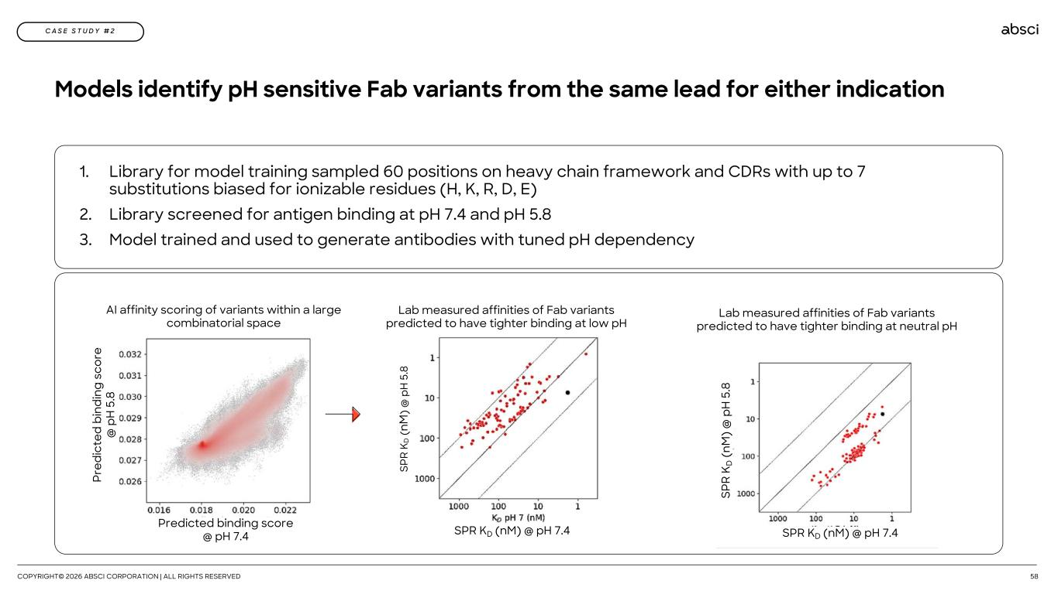
Models identify pH sensitive Fab variants from the same lead for either indication COPYRIGHT© 2026 ABSCI CORPORATION | ALL RIGHTS RESERVED 58 C A S E S T U D Y # 2 1. Library for model training sampled 60 positions on heavy chain framework and CDRs with up to 7 substitutions biased for ionizable residues (H, K, R, D, E) 2. Library screened for antigen binding at pH 7.4 and pH 5.8 3. Model trained and used to generate antibodies with tuned pH dependency Pr ed ic te d bi nd in g sc or e @ p H 5 .8 Predicted binding score @ pH 7.4 AI affinity scoring of variants within a large combinatorial space SP R K D (n M ) @ p H 5 .8 SPR KD (nM) @ pH 7.4 Lab measured affinities of Fab variants predicted to have tighter binding at low pH Lab measured affinities of Fab variants predicted to have tighter binding at neutral pH SP R K D ( nM ) @ p H 5 .8 SPR KD (nM) @ pH 7.4

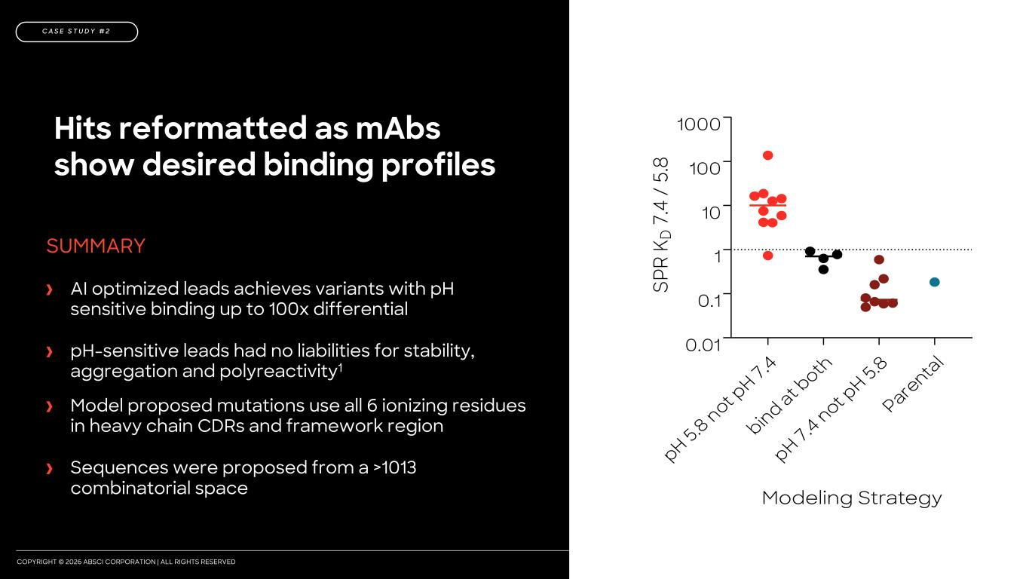
COPYRIGHT © 2026 ABSCI CORPORATION | ALL RIGHTS RESERVED 2024 20252024 2025 2026 Hits reformatted as mAbs show desired binding profiles SUMMARY AI optimized leads achieves variants with pH sensitive binding up to 100x differential pH-sensitive leads had no liabilities for stability, aggregation and polyreactivity1 Model proposed mutations use all 6 ionizing residues in heavy chain CDRs and framework region Sequences were proposed from a >1013 combinatorial space pH 5.8 not p H 7.4 bind at b oth pH 7.4 not p H 5.8 Pare nta l 0.01 0.1 1 10 100 1000 Modeling Strategy SP R K D 7 .4 / 5. 8 SOURCE: 1 Data provided in appendix C A S E S T U D Y # 2

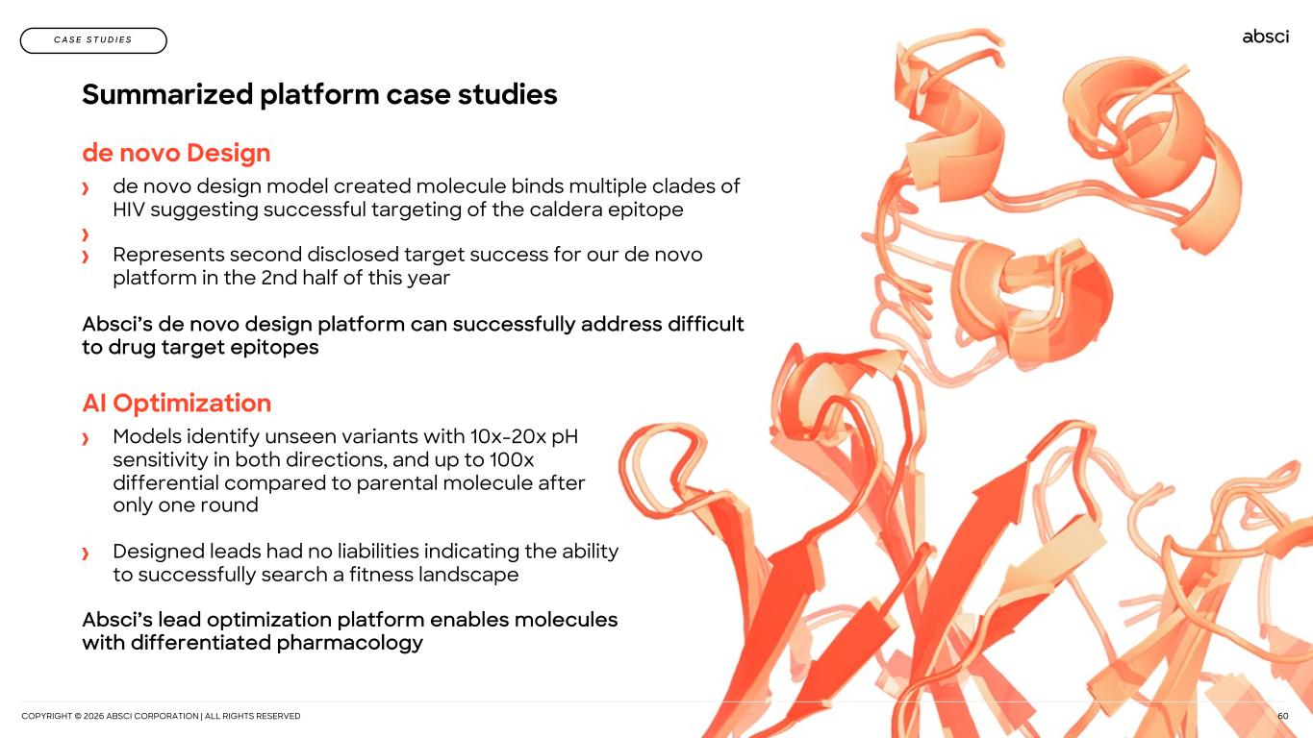
COPYRIGHT © 2026 ABSCI CORPORATION | ALL RIGHTS RESERVED 60 Summarized platform case studies C A S E S T U D I E S de novo Design de novo design model created molecule binds multiple clades of HIV suggesting successful targeting of the caldera epitope Represents second disclosed target success for our de novo platform in the 2nd half of this year Absci’s de novo design platform can successfully address difficult to drug target epitopes space AI Optimization Models identify unseen variants with 10x-20x pH sensitivity in both directions, and up to 100x differential compared to parental molecule after only one round Designed leads had no liabilities indicating the ability to successfully search a fitness landscape Absci’s lead optimization platform enables molecules with differentiated pharmacology space

